UNITED STATES

SECURITIES AND EXCHANGE COMMISSION
Washington, D.C. 20549

FORM 10-Q

- QUARTERLY REPORT PURSUANT TO SECTION 13 OR 15(d) OF THE SECURITIES EXCHANGE ACT OF 1934 For the quarterly period ended March 31, 2026

or

- TRANSITION REPORT PURSUANT TO SECTION 13 OR 15(d) OF THE SECURITIES EXCHANGE ACT OF 1934 For the transition period from ___________ to ___________

Commission File Number: 001-42275

 | KAIROS PHARMA, LTD.
 | (Exact name of registrant as specified in its charter)
Delaware | 46-2993314
(State or other jurisdiction of |  |  | (I.R.S Employer
incorporation or organization) |  |  | Identification No.)
 | 2355 Westwood Blvd., #139
 | Los Angeles CA 90064
 | (Address of principal executive offices) (Zip Code)

(310) 948-2356

(Registrant’s telephone number, including area code)

N/A

(Former name, former address and former fiscal year, if changed since last report)

Securities registered pursuant to Section 12(b) of the Act:
Title of each class |  | Trading Symbol(s) |  | Name of each exchange on which registered
Common Stock, par value $0.001 per share |  | KAPA |  | NYSE American

Indicate by check mark whether the registrant (1) has filed all reports required to be filed by Section 13 or 15(d) of the Securities Exchange Act of 1934 during the preceding 12 months (or for such shorter period that the registrant was required to file such reports), and (2) has been subject to such filing requirements for the past 90 days. Yes ☒ No ☐

Indicate by check mark whether the registrant has submitted electronically every Interactive Data File required to be submitted pursuant to Rule 405 of Regulation S-T (§232.405 of this chapter) during the preceding 12 months (or for such shorter period that the registrant was required to submit such files). Yes ☒ No ☐

Indicate by check mark whether the registrant is a large accelerated filer, an accelerated filer, a non-accelerated filer, a smaller reporting company, or an emerging growth company. See the definitions of “large accelerated filer,” “accelerated filer,” “smaller reporting company,” and “emerging growth company” in Rule 12b-2 of the Exchange Act.

Large accelerated filer ☐

Non-accelerated filer ☒

Accelerated filer ☐

Smaller reporting company ☒

Emerging growth company ☒

If an emerging growth company, indicate by check mark if the registrant has elected not to use the extended transition period for complying with any new or revised financial accounting standards provided pursuant to Section 13(a) of the Exchange Act. ☐

Indicate by check mark whether the registrant is a shell company (as defined in Rule 12b-2 of the Exchange Act.) Yes ☐ No ☒

The number of shares issued and outstanding of the registrant’s common stock on May 11, 2026 was 21,411,198.

 |  |  |  |  |  |  |  |  |  |  | KAIROS PHARMA, LTD.
 |  |  |  |  |  |  |  |  |  |  |  |  | TABLE OF CONTENTS
 | PART I - FINANCIAL INFORMATION
 | Item 1. | Financial Statements
 |  | Unaudited Condensed Consolidated Balance Sheets as of March 31, 2026 and December 31, 2025 |  |  |  |  |  |  |  |  |  |  |  |  |  |  |  |  | 3
 |  | Unaudited Condensed Consolidated Statements of Operations for the Three Months Ended March 31, 2026 and 2025 |  |  |  |  |  |  |  |  |  |  |  |  |  |  |  |  | 4
 |  | Unaudited Condensed Consolidated Statements of Shareholders’ Equity (Deficit) for the Three Months Ended March 31, 2026 and 2025 |  |  |  |  |  |  |  |  |  |  |  |  |  |  |  |  | 5
 |  | Unaudited Condensed Consolidated Statements of Cash Flows for the Three Months Ended March 31, 2026 and 2025 |  |  |  |  |  |  |  |  |  |  |  |  |  |  |  |  | 6
 |  | Notes to Unaudited Condensed Consolidated Financial Statements |  |  |  |  |  |  |  |  |  |  |  |  |  |  |  |  | 7
 | Item 2. | Management’s Discussion and Analysis of Financial Condition and Results of Operations |  |  |  |  |  |  |  |  |  |  |  |  |  |  |  |  | 17
 | Item 3 | Quantitative and Qualitative Disclosures About Market Risk |  |  |  |  |  |  |  |  |  |  |  |  |  |  |  |  | 27
 | Item 4. | Control and Procedures |  |  |  |  |  |  |  |  |  |  |  |  |  |  |  |  | 27
 | PART II - OTHER INFORMATION |  |  |  |  |  |  |  |  |  |  |  |  |  |  |  |  |  | 28
 | Item 1 | Legal Proceedings |  |  |  |  |  |  |  |  |  |  |  |  |  |  |  |  | 28
 | Item 1A | Risk Factors |  |  |  |  |  |  |  |  |  |  |  |  |  |  |  |  | 28
 | Item 2. | Unregistered Sales of Equity Securities and Use of Proceeds |  |  |  |  |  |  |  |  |  |  |  |  |  |  |  |  | 28
 | Item 3. | Defaults Upon Senior Securities |  |  |  |  |  |  |  |  |  |  |  |  |  |  |  |  | 28
 | Item 4. | Mine Safety Disclosures |  |  |  |  |  |  |  |  |  |  |  |  |  |  |  |  | 28
 | Item 5. | Other Information |  |  |  |  |  |  |  |  |  |  |  |  |  |  |  |  | 28
 | Item 6. | Exhibits |  |  |  |  |  |  |  |  |  |  |  |  |  |  |  |  | 29
 | SIGNATURES |  |  |  |  |  |  |  |  |  |  |  |  |  |  |  |  |  | 30
 |  |  | 2

Current Assets

Cash and cash equivalents Vendor advances, net
Prepaid expenses and other current assets Total Current Assets

Deferred offering costs

Intangible assets, net

Total Other Assets

TOTAL ASSETS

Kairos Pharma, Ltd.

Condensed Consolidated Balance Sheets (unaudited)

(In thousands, except for share amounts and par value data)

 |  | March 31, |  |  | December 31,
 |  | 2026 |  |  | 2025
ASSETS |  | (Unaudited)
$ |  | 3,675 |  | $ | 4,491
 |  | 625 |  |  | 845
 |  | 143 |  |  | 51
 |  | 4,443 |  |  | 5,387
 |  | 1,279 |  |  | 1,091
 |  | 22 |  |  | 62
 |  | 1,301 |  |  | 1,153
$ |  | 5,744 |  | $ | 6,540

 | LIABILITIES AND SHAREHOLDERS’ EQUITY
 | Current Liabilities
 | Accounts payable and accrued expenses | $ |  | 431 |  | $ | 199
 | Total Current Liabilities |  |  | 431 |  |  | 199
 | Commitments and contingencies
 | Shareholders’ Equity
 | Preferred stock, par value $0.001, 20,000,000 shares authorized; no shares issued and outstanding, respectively; |  |  | - |  |  | -
 | Common stock, par value $0.001, 100,000,000 shares authorized; 21,411,198 and 20,821,353 shares issued and
 | outstanding, respectively; |  |  | 21 |  |  | 21
 | Additional paid-in capital |  |  | 21,208 |  |  | 20,582
 | Accumulated deficit |  |  | (15,916) |  |  | (14,262)
 | Total Shareholders’ Equity |  |  | 5,313 |  |  | 6,341
 | TOTAL LIABILITIES AND SHAREHOLDERS’ EQUITY | $ |  | 5,744 |  | $ | 6,540
 | The accompanying notes are an integral part of these condensed consolidated financial statements.
 | 3

Kairos Pharma, Ltd.

Condensed Consolidated Statements of Operations (unaudited)

(in thousands, except for share amounts and per share data)

 |  |  |  | Three Months Ended
 |  |  |  | March 31,
 |  |  |  | 2026 |  |  | 2025
 |  |  |  | (Unaudited)
 | Revenues | $ |  | - |  | $ | -
 | Operating expenses:
 | Research and development |  |  | 684 |  |  | 493
 | General and administrative |  |  | 1,006 |  |  | 773
 | Total operating expenses |  |  | 1,690 |  |  | 1,266
 | Loss from operations |  |  | (1,690) |  |  | (1,266)
 | Other income:
 | Interest income |  |  | 36 |  |  | 4
 | Total other income |  |  | 36 |  |  | 4
 | NET LOSS | $ |  | (1,654) |  | $ | (1,262)
 | BASIC AND DILUTED LOSS PER COMMON SHARE | $ |  | (0.08) |  | $ | (0.08)
 | WEIGHTED-AVERAGE COMMON SHARES OUTSTANDING
 | BASIC AND DILUTED |  |  | 21,010,132 |  |  | 15,875,485

The accompanying notes are an integral part of these condensed consolidated financial statements.

4

Balance, March 31, 2025 (unaudited)
Fair value of vested restricted stock units
Balance, December 31, 2024
Balance, March 31, 2026 (unaudited)
Fair value of vested restricted stock units
Balance, December 31, 2025
Kairos Pharma, Ltd.

Condensed Consolidated Statements of Shareholders’ Equity (Unaudited)

(in thousands, except share amounts)

 |  | Common Stock |  |  |  |  |  |  | Additional |  |  |  | Accumulated
 |  | Shares |  |  |  | Amount |  |  | Paid-in Capital |  |  |  | Deficit |  |  |  | Total
 |  | 20,821,353 |  | $ |  | 21 |  | $ | 20,582 |  | $ |  | (14,262) |  | $ |  | 6,341
 | Issuance of common shares sold through the At the
 | Market (ATM) offering, net of offering costs | 589,845 |  |  |  | - |  |  | 367 |  |  |  | - |  |  |  | 367
 |  | - |  |  |  | - |  |  | 259 |  |  |  | - |  |  |  | 259
 | Net loss for the three months ended March 31, 2026 | - |  |  |  | - |  |  | - |  |  |  | (1,654) |  |  |  | (1,654)
 |  | 21,411,198 |  | $ |  | 21 |  | $ | 21,208 |  | $ |  | (15,916) |  | $ |  | 5,313
 |  | 13,736,597 |  | $ |  | 14 |  | $ | 13,577 |  | $ |  | (8,815) |  | $ |  | 4,776
 | Proceeds from the sale of pre-funded warrants, net of
 | offering costs | - |  |  |  | - |  |  | 3,056 |  |  |  | - |  |  |  | 3,056
 | Issuance of common shares upon the exercise of pre-
 | funded warrants | 2,010,000 |  |  |  | 2 |  |  | - |  |  |  | - |  |  |  | 2
 | Fair value of common shares to be issued for vendor
 | advance and deferred offering costs | 551,000 |  |  |  | - |  |  | 484 |  |  |  | - |  |  |  | 484
 |  | 78,521 |  |  |  | - |  |  | 76 |  |  |  | - |  |  |  | 76
 | Net loss for the three months ended March 31, 2025 | - |  |  |  | - |  |  | - |  |  |  | (1,262) |  |  |  | (1,262)
 |  | 16,376,118 |  | $ |  | 16 |  | $ | 17,193 |  | $ |  | (10,077) |  | $ |  | 7,132

The accompanying notes are an integral part of these condensed consolidated financial statements.

5

Kairos Pharma, Ltd.

Condensed Consolidated Statements of Cash Flows (unaudited)

(In thousands)

 |  |  |  |  | Three Months Ended
 |  |  |  |  |  | March 31,
 |  |  |  |  | 2026 |  |  | 2025
 |  |  |  |  |  | (Unaudited)
 | Cash Flows from Operating Activities
 | Net loss |  |  | $ |  | (1,654) |  | $ | (1,262)
 | Adjustments to reconcile net loss to net cash used in operating activities:
 | Amortization of intangible asset |  |  |  |  | 40 |  |  | 40
 | Amortization of vendor advances |  |  |  |  | 220 |  |  | -
 | Fair value of vested restricted stock units |  |  |  |  | 259 |  |  | 76
 | Changes in operating assets and liabilities:
 | Vendor advances |  |  |  |  | - |  |  | 636
 | Prepaid expenses and other current assets |  |  |  |  | (92) |  |  | (17)
 | Accounts payable and accrued expenses |  |  |  |  | 191 |  |  | (187)
 | Net cash used in operating activities |  |  |  |  | (1,036 | ) |  | (714 | )
 | Cash Flows from Financing Activities
 | Proceeds from the At the Market (ATM) offering |  |  |  |  | 385 |  |  | -
 | Proceeds from the sale and exercise of prefunded warrants |  |  |  |  | - |  |  | 3,058
 | Payment of deferred offering costs |  |  |  |  | (165) |  |  | -
 | Net cash provided by financing activities |  |  |  |  | 220 |  |  | 3,058

Net increase (decrease) in cash and cash equivalents

Cash and cash equivalents, beginning of period

Cash and cash equivalents, end of period

 |  | (816) |  |  | 2,344
 |  | 4,491 |  |  | 1,272
 | $ | 3,675 |  | $ | 3,616

 | Supplemental cash flows disclosures:
 | Interest paid |  |  | $ |  | - |  | $ | -
 | Taxes paid |  |  |  | $ | - |  | $ | -
 | Supplemental non-cash financing disclosures:
 | Common shares issued for deferred offering costs |  |  | $ |  | - |  | $ | 328
 | Common shares issued for vendor advances |  |  |  | $ | - |  | $ | 156
 | Reclassification of deferred offering costs to shareholders’ equity
 |  |  |  |  | $ | 18 |  | $ | -
 | Accrual of deferred offering costs |  |  |  | $ | 41 |  | $ | -

The accompanying notes are an integral part of these condensed consolidated financial statements.

6

KAIROS PHARMA, LTD.

NOTES TO CONDENSED CONSOLIDATED FINANCIAL STATEMENTS (UNAUDITED)

FOR THE THREE MONTHS ENDED MARCH 31, 2026 AND 2025

(In thousands, except for share amounts and per share data)

NOTE 1 – BASIS OF PRESENTATION

Organization and Operations

Kairos Pharma, Ltd. (the “Company” or “Kairos”) was incorporated on June 17, 2013 under the laws of the state of California as NanoGB13, Inc. The Company changed its name to Kairos Pharma, Ltd. on July 15, 2016 and subsequently converted into a Delaware corporation under the same name, Kairos Pharma, Ltd., on May 10, 2023. The Company is an early-stage biotechnology company focused on the development of immunotherapy and cell therapy treatments for oncology.

Basis of Presentation of Unaudited Financial Information

The accompanying unaudited condensed financial statements of the Company have been prepared in accordance with accounting principles generally accepted in the United States for interim financial information and the instructions to Form 10-Q and Rule 10-01 of Regulation S-X. Accordingly, they do not include all of the information and footnotes required by generally accepted accounting principles for complete financial statements. In the opinion of management, all normal recurring adjustments considered necessary for a fair presentation have been included. Operating results for the three months ended March 31, 2026, are not necessarily indicative of the results that may be expected for the year ending December 31, 2026. The balance sheet information as of December 31, 2025 was derived from the audited financial statements included in the Company’s financial statements as of and for the years ended December 31, 2025 and 2024 contained in the Company’s Annual Report on Form 10-K filed with the Securities and Exchange Commission. These financial statements should be read in conjunction with that report.

Liquidity and Capital Resources

The accompanying condensed consolidated financial statements have been prepared on a going concern basis, which contemplates the realization of assets and the settlement of liabilities and commitments in the normal course of business. As reflected in the accompanying condensed consolidated financial statements, the Company has experienced recurring losses from operations since inception and incurred a net loss of $1,654 and used cash in operations of $1,036 during the three months ended March 31, 2026. These factors raise substantial doubt about the Company’s ability to continue as a going concern. In addition, the Company’s independent registered public accounting firm, in its report on the Company’s December 31, 2025 financial statements, has expressed substantial doubt about the Company’s ability to continue as a going concern. The ability of the Company to continue as a going concern is dependent upon the Company’s ability to raise additional funds and implement its strategies. The financial statements do not include any adjustments that might be necessary if the Company is unable to continue as a going concern.

As of March 31, 2026, the Company had cash and short-term investments of $3,675. Until the Company can generate sufficient product revenue to finance our cash requirements, which we may never do, we expect to finance our future cash needs through a combination of public or private equity offerings and debt financings, or other capital sources such as potential collaborations, strategic alliances, licensing arrangements and other arrangements. Based on our research and development plans, we expect that our existing cash balance may not enable us to fund our planned operating expenses and capital expenditure requirements for at least the next 12 months from the date of filing of this report. We have based this estimate on assumptions that may prove to be wrong, and we could exhaust our available capital resources sooner than we expect. In addition, because the design and outcome of our anticipated and any future clinical trials is highly uncertain, we cannot reasonably estimate the actual amounts necessary to successfully complete the development and commercialization of our current products or any future product candidates. Additionally, although we have the ability to raise funds through our Form S-1 and S-3 registration statements filed in 2025 and 2026, we may not receive some or all of these available proceeds, due to certain factors. The failure to receive all or some of the proceeds would exhaust our available capital resources sooner than expected and will require us to obtain further funding to achieve our business objectives.

7

No assurance can be given that any future financing will be available or, if available, that it will be on terms that are satisfactory to the Company. Even if the Company is able to obtain additional financing, it may contain undue restrictions on our operations, in the case of debt financing, or cause substantial dilution for our shareholders, in the event of an equity financing.

NOTE 2 - SUMMARY OF SIGNIFICANT ACCOUNTING POLICIES

Basis of Consolidation

The accompanying condensed consolidated financial statements and accompanying notes have been prepared in accordance with accounting principles generally accepted in the United States of America (“U.S. GAAP”). The accompanying consolidated financial statements include the accounts of the Company and its former wholly-owned subsidiary, Enviro Therapeutics, Inc. (“Enviro”) which was dissolved in October 2025. All intercompany balances and transactions have been eliminated in consolidation.

Use of Estimates

The preparation of the financial statements in conformity with accounting principles generally accepted in the U.S. requires management to make estimates and assumptions that affect the reported amounts of assets and liabilities, disclosure of contingent assets and liabilities at the financial statement date and reported amounts of revenue and expenses during the reporting period. Significant estimates are used in the valuation of accruals for potential liabilities, amortization of vendor advances and deferred offering costs, valuations of stock-based compensation, the realization of deferred tax assets, and impairment analysis and useful life for intangible assets among others. Actual results could differ from these estimates.

Concentration of Credit Risk

Financial instruments, which potentially subject the Company to concentration of credit risk, consist primarily of cash deposits. The Company maintains deposits in federally insured financial institutions in excess of federally insured limits. Management believes that the Company is not exposed to significant credit risk due to the financial position of the depository institutions in which those deposits are held. The Company has not experienced any losses on deposits since its inception.

Cash Equivalents

The Company considers all highly liquid investments with original maturities of three months or less on the date of purchase to be cash equivalents. The Company’s cash equivalents consisted of $3,612 and $4,326 in money market funds as of March 31, 2026, and December 31, 2025, respectively. The underlying securities in the money market funds held by the Company are all government backed securities.

Intangible Assets

The Company’s intangible assets are stated at fair value as of the date acquired, less accumulated amortization. Amortization is calculated based on the estimated useful lives of the assets, which were determined to be five years, using the straight-line method. The intangible asset consists of a licensing agreement that the Company acquired through its acquisition of Enviro during the year ended December 31, 2021, with an acquisition cost of $800. Amortization expense relating to the intangible asset during each of the three months ended March 31, 2026 and 2025 was $40, respectively, with an unamortized balance of $22 and $62 at March 31, 2026 and December 31, 2025, respectively.

Impairment of Long-Lived Assets

The Company applies the provisions of ASC Topic 360, Property, Plant, and Equipment, which addresses financial accounting and reporting for the impairment of long-lived assets. A long-lived asset that is held and used should be tested for recoverability whenever events or changes in circumstances indicate that the carrying amount of the asset group may not be recoverable. If the estimated undiscounted future cash flows are less than the carrying value, an impairment determination is required. In that event, a loss is recognized based on the amount by which the carrying amount exceeds the fair value of the long-lived assets. No impairment was recorded relating to the Company’s intangible asset during the three months ended March 31, 2026 and 2025.

8

Income (Loss) Per Share

Basic loss per share is computed by dividing net loss applicable to common stockholders by the weighted average number of outstanding common shares during the period. Shares of restricted stock are included in the basic weighted average number of common shares outstanding from the time they vest. Diluted loss per share is computed by dividing the net loss applicable to common stockholders by the weighted average number of common shares outstanding plus the number of additional common shares that would have been outstanding if all dilutive potential common shares had been issued.

For the three months ended March 31, 2026 and 2025, the basic and diluted shares outstanding were the same, as potentially dilutive shares were considered anti-dilutive. The potentially dilutive securities consisted of the following:

 | March 31, 2026 |  | March 31, 2025
Warrants to purchase common stock | 4,281,038 |  | 4,543,188
Restricted stock units | 772,605 |  | 113,599
Total | 5,053,643 |  | 4,656,787

Deferred Offering Costs

The Company capitalizes certain legal, professional, accounting and other third-party fees that are directly associated with in-process equity issuances as deferred offering costs until such equity issuances are consummated. After consummation of the equity issuance, these costs are recorded as a reduction in the capitalized amount associated with the equity issuance. Should the equity issuance be delayed or abandoned, the deferred offering costs will be expensed immediately as a charge to operating expenses in the Company’s statement of operations. As of December 31, 2025, the net balance of the of deferred offering costs relating to the Company’s equity line of credit (“ELOC”) offering was $1,091. During the three months ended March 31, 2026, no additional offering costs were incurred and no cost of capital was amortized relating to the ELOC, leaving a net balance of $1,091 at March 31, 2026.

During the three months ended March 31, 2026, $206 of deferred offering costs were incurred relating to the Company’s At the Market (“ATM”) offering (see Notes 4 and 5) and $18 was amortized as cost of capital relating to that offering, leaving a net balance of $188 at March 31, 2026.

Total net deferred offering costs were $1,279 at March 31, 2026 relating to the ELOC and the ATM.

Fair Value Measurements

The Company determines the fair value of its assets and liabilities based on the exchange price in U.S. dollars that would be received to sell an asset or paid to transfer a liability (an exit price) in the principal or most advantageous market for the asset or liability in an orderly transaction between market participants on the measurement date. Valuation techniques used to measure fair value maximize the use of observable inputs and minimize the use of unobservable inputs. The Company uses a fair value hierarchy with three levels of inputs, of which the first two are considered observable and the last unobservable, to measure fair value:

- Level 1 — Quoted prices in active markets for identical assets or liabilities.

- Level 2 — Inputs, other than Level 1, that are observable, either directly or indirectly, such as quoted prices for similar assets or liabilities; quoted prices in markets that are not active; or other inputs that are observable or can be corroborated by observable market data for substantially the full term of the assets or liabilities.

- Level 3 — Unobservable inputs that are supported by little or no market activity and that are significant to the fair value of the assets or liabilities.

The carrying amounts of financial instruments such as cash, and accounts payable and accrued liabilities, approximate the related fair values due to the short-term maturities of these instruments.

9

Cash equivalents consisted of money market funds at March 31, 2026 and December 31, 2025. Money market funds were valued by the Company using quoted prices in active markets for identical securities, which represent a Level 1 measurement within the fair value hierarchy.

Recent Accounting Pronouncements

In November 2024, FASB issued ASU 2024-03 Income Statement—Reporting Comprehensive Income—Expense Disaggregation Disclosures (Subtopic 220-40) Disaggregation of Income Statement Expenses. The guidance in ASU 2024-03 requires public business entities to disclose in the notes to the financial statements, among other things, specific information about certain costs and expenses including purchases of inventory; employee compensation; and depreciation and amortization expense for each caption on the income statement where such expenses are included. The update is effective for annual reporting periods beginning after December 15, 2026, and interim reporting periods beginning after December 15, 2027. Early adoption is permitted, and the amendments may be applied prospectively to reporting periods after the effective date or retrospectively to all periods presented in the financial statements. We are currently evaluating the provisions of this guidance and assessing the potential impact on our financial statement disclosures.

In September 2025, the FASB issued ASU No. 2025-06, “Intangibles-Goodwill and Other-Internal-Use Software,” which revises the guidance for capitalizing costs related to internal-use software to better reflect modern, iterative and agile development practices. This ASU plans to remove project stage references and instead will focus on a new capitalization criteria: (i) management has authorized and committed to the software project and (ii) project completion probability. This ASU requires companies to evaluate whether significant development uncertainty exists before capitalizing costs and also incorporates website development guidance into Subtopic 350-40. This ASU is effective for annual and interim periods beginning after December 15, 2027, with early adoption permitted. The Company is currently evaluating the impact of this update on its consolidated financial statements.

Other recent accounting pronouncements issued by the FASB, including its Emerging Issues Task Force, the American Institute of Certified Public Accountants, and the Securities and Exchange Commission did not or are not believed by management to have a material impact on the Company’s present or future consolidated financial statements.

NOTE 3 – VENDOR AGREEMENTS

Vendor Advances

The Company has entered into various contracts with service providers pursuant to which the Company pays the vendor an advance at the beginning of the contractual period. These vendor advances could be paid by the Company either in cash or in shares of common stock, depending on the terms of the contract. The advances are reduced by the accumulated value of the services performed by the vendor or are amortized on a straight-line basis over the service period, whichever is shorter. As of December 31, 2025, advances to vendors totaled $845. Amortization expense relating to the vendor advances during the three months ended March 31, 2026 was $220, with an unamortized balance of $625 as of March 31, 2026.

Vendor advances consisted of the following at March 31, 2026 and December 31, 2025:
 |  | March 31, 2026 |  |  | December 31, 2025
Prevail Infoworks (a) | $ | 900 |  | $ | 900
Cross Current Capital (b) |  | 856 |  |  | 856
 |  | 1,756 |  |  | 1,756
Less: accumulated amortization |  | (1,131) |  |  | (911)
Vendor advances, net | $ | 625 |  | $ | 845

The remaining unamortized balance of $625 as of March 31, 2026, will be fully amortized during the year ending December 31, 2026.

(a) Kairos Agreement with Prevail Infoworks, Inc.

On August 1, 2024, the Company entered into a master service and technology agreement with Prevail Infoworks, Inc. (“Prevail”), pursuant to which Prevail agreed to provide certain clinical research services to the Company. As part of the agreement, the Company was required to make an advance payment of $900 to Prevail before commencement of services and, at such time as we notify Prevail to engage their services related to the relevant clinical trial, or six months from the date of the agreement, pay approximately $80 per month during the time Prevail performs clinical research services for the Company’s Phase 2 ENV 105 prostate and Phase 1 ENV 105 lung clinical trials. The agreement with Prevail is subject to cancellation at any time upon 30 days’ written notice to the other party. The Company made the $900 advance payment to Prevail in October 2024 and it is included in vendor advances on the accompanying Balance Sheets as of March 31, 2026, and December 31, 2025. The unamortized balance of the advance was $400 as of March 31, 2026.

10

(b) Kairos Agreement with Cross Current Capital LLC

On October 1, 2024, the Company entered into a consulting agreement (the “Consulting Agreement”) with Cross Current Capital LLC, a limited liability company organized under the laws of Puerto Rico (“Cross Current”), and Alan Masley (the “Advisor”), pursuant to which Cross Current agreed to provide certain financial and business consulting services to the Company including, but not limited, to (a) help drafting a public company competitive overview, (b) help preparing and/or reviewing a valuation analysis, (c) help in drafting marketing materials and presentations, (d) reviewing the Company’s business requirements and discuss financing and businesses opportunities, (e) investor marketing, (f) investor relations introductions, (g) legal counsel introductions, (h) auditor introductions, (i) investment banking and research introductions, (j) M&A canvassing and ways to grow the business organically, and (k) stand by capital markets advisory services. For the services rendered thereunder, the Company agreed to pay Cross Current $200 in cash and agreed to issue to the Advisor $500 of restricted shares of the Company’s common stock under the Company’s 2023 Plan. The payment of $200 and the value of the shares, both totaling $856, are included in vendor advances on the accompanying Balance Sheets as of March 31, 2026 and December 31, 2025. The unamortized balance of the advances was $225 at March 31, 2026.

NOTE 4 – DEFERRED OFFERING COSTS

Agreement with Helena Global Investment Opportunities

On November 12, 2024, the Company entered into an agreement with Helena Global Investment Opportunities I LTD (“Helena”) pursuant to which the Company will have the right to issue and sell to Helena, from time to time, and Helena shall purchase from the Company, up to $30,000 of the Company’s shares of common stock (the “Equity Line of Credit”). The Equity Line of Credit became available to the Company after the Company filed a registration statement on Form S-1 registering the shares issuable under the Equity Line of Credit and such registration statement became effective. In exchange for the Equity Line of Credit, the Company is obligated to issue Helena a certain number of shares of common stock, calculated using $900 divided by the lowest one-day VWAP during the five trading days prior to entry into the agreement. As a result, the Company issued Helena 670,641 shares of its common stock valued at $1,377 on the date of issuance. The Company accounted for the value of the shares issued as deferred offering costs. The shares vested on the date of the agreement, were issued to Helena, and were subject to a “true up” based upon the value of the stock after the company filed and obtained effectiveness of the registration statement registering the ELOC shares for resale.

At December 31, 2025, the balance of the deferred offering costs relating to Helena was $1,091. During the three months ended March 31, 2026, no funds were raised under the ELOC, and as such, the Company did not amortize any of these costs. As of March 31, 2026, the balance of the deferred offering costs relating to Helena was $1,091, which costs will be amortized and recognized as cost of capital upon further issuances of common stock under the ELOC.

At the Market (ATM) Offering Agreement

In January 2026, the Company filed a shelf registration statement on Form S-3, registering up to $75,000 in aggregate securities and, in conjunction therewith, filed a prospectus supplement for the sale of up to $4,500 of common stock pursuant to an ATM Agreement (see Note 5). Deferred offering costs incurred relating to the ATM were $206 during the three months ended March 31, 2026. During the three months ended March 31, 2026, the Company amortized $18 of these costs, and as of March 31, 2026, the balance of the deferred offering costs relating to the ATM was $188. These costs will be amortized and recognized as cost of capital upon further issuances of common stock under the ATM.

As of March 31, 2026, the total balance of the deferred offering costs was $1,279.

11

NOTE 5 – SHAREHOLDERS’ EQUITY

Common Stock

At the Market (ATM) Offering

In January 2026, the Company filed a shelf registration statement on Form S-3, registering up to $75,000 in aggregate securities and, in conjunction therewith, filed a prospectus supplement for the sale of up to $4,500 of common stock pursuant to an At the Market Offering Agreement (the “ATM Agreement”) with H.C. Wainwright and Co., LLC (the “Placement Agent”). Under the ATM Agreement, the Placement Agent will be entitled to 3.0% of the gross proceeds of any sales made under the ATM Agreement. As a result of the ATM offering, during the three months ended March 31, 2026, the Company raised gross proceeds of $385 through the sale of 589,845 shares of its common stock. Net proceeds were $367 after the deduction of offering costs.

Common Stock Issued for Cash Upon Closing of the Company’s Private Financing

On January 14, 2025, the Company entered into a securities purchase agreement (“SPA”) and registration rights agreement with an investor for the sale and issuance of 2,500,000 units (the “Pre-Funded Units”), with each Pre-Funded Unit consisting of a pre-funded warrant to purchase one share of common stock, exercisable for $0.001 per share, and a common warrant to purchase one and one half shares of common stock (an aggregate of 3,750,000), exercisable at $1.399 per share. On January 16, 2025, the Company closed on the sale of the Pre-Funded Units for a total purchase price of $3,500 (or $1.40 per Pre-Funded Unit). Net proceeds received by the Company relating to the financing, and subsequent exercise of prefunded warrants was $3,058.

The pre-funded warrants have an exercise price of $0.001 per share and are immediately exercisable and will expire when exercised in full. The common warrants have an exercise price of $1.40 per share, will be exercisable six months from issuance and will expire five and a half years from the issuance date. During the year ended December 31, 2025, the investor exercised 2,500,000 shares of the pre-funded warrants and as of December 31, 2025, there were no pre-funded shares remaining unexercised.

Adoption of the 2023 Equity Incentive Plan

In July 2023, the Company’s board of directors and stockholders adopted the 2023 Equity Incentive Plan (the “2023 Plan”). Under the 2023 Plan, the Company may grant incentive stock options to employees, including employees of any parent or subsidiary, and nonstatutory stock options, stock appreciation rights, restricted stock awards, RSU awards, performance awards and other forms of stock compensation to employees, directors and consultants, including employees and consultants of the Company’s affiliates. As approved, a total of 1,650,000 shares of common stock were initially reserved for issuance under the 2023 Plan. As of each of March 31, 2026, and December 31, 2025, a total of 877,395 shares remained available for issuance under the 2023 Plan, respectively.

Grant of Restricted Stock Units (RSUs)

The following table summarizes restricted common stock activity during the three months ended March 31, 2026:

 |  |  |  |  |  |  |  | Weighted Average
 | Number of |  |  |  |  |  |  | Grant Date Fair
 | Restricted Shares |  | Fair Value |  |  |  |  | Value
Unvested, December 31, 2025 | 772,605 |  |  | 813 |  |  |  | 1.05
Granted | — |  |  | — |  |  |  | —
Vested | — |  |  | (259) |  |  |  | —
Forfeited | — |  |  | — |  |  |  | —
Unvested, March 31, 2026 | 772,605 |  | $ | 554 |  |  | $ | 1.05

During the three months ended March 31, 2026 and 2025, the Company recorded $259 and $76, respectively, of stock compensation-related expense for the fair value vesting of restricted common stock. As of March 31, 2026, $554 of unamortized compensation remained.

12

Stock Warrants
The table below summarizes the Company’s warrant activities for the three months ended March 31, 2026:
 |  |  |  |  |  |  |  |  |  |  |  |  |  |  |  |  |  |  |  |  | Exercise |  |  |  |  |  | Weighted
 |  |  |  |  |  |  |  |  |  |  |  |  |  |  | Number of |  |  |  |  |  | Price |  |  |  |  |  | Average
 |  |  |  |  |  |  |  |  |  |  |  |  |  |  | Warrant |  |  |  |  |  | Range |  |  |  |  |  | Exercise
 |  |  |  |  |  |  |  |  |  |  |  |  |  |  | Shares |  |  |  | Per Share |  |  |  |  |  |  |  |  |  |  | Price
 | Balance, December 31, 2025 |  |  |  |  |  |  |  |  |  |  |  |  |  | 4,281,038 |  |  |  |  |  | 0.40 - 4.80 |  |  |  |  |  |  |  |  | 1.48
 | Granted |  |  |  |  |  |  |  |  |  |  |  |  |  |  |  | — |  |  |  |  | — |  |  |  |  |  |  |  | —
 | Cancelled |  |  |  |  |  |  |  |  |  |  |  |  |  |  |  | — |  |  |  |  | — |  |  |  |  |  |  |  | —
 | Exercised |  |  |  |  |  |  |  |  |  |  |  |  |  |  |  | — |  |  |  |  | — |  |  |  |  |  |  |  | —
 | Forfeited/Expired |  |  |  |  |  |  |  |  |  |  |  |  |  |  |  | — |  |  |  |  | — |  |  |  |  |  |  |  | —
 | Balance, March 31, 2026 |  |  |  |  |  |  |  |  |  |  |  |  |  | 4,281,038 |  |  |  | $ |  |  | 0.40 – 4.80 |  |  | $ |  |  |  |  | 1.48
 | Vested and exercisable, March 31, 2026 |  |  |  |  |  |  |  |  |  |  |  |  |  | 4,281,038 |  |  |  | $ |  |  | 0.40 – 4.80 |  |  | $ |  |  |  |  | 1.48
The following table summarizes information concerning outstanding and exercisable warrants as of March 31, 2026:
 |  |  |  |  |  |  |  | Warrants Outstanding |  |  |  |  |  |  |  |  |  |  |  |  | Warrants Exercisable
 |  |  |  |  |  |  |  |  |  |  |  |  |  |  |  |  |  |  |  |  |  | Average
 |  |  |  |  |  |  |  |  | Average |  |  |  | Weighted |  |  |  |  |  |  |  |  | Remaining |  |  |  |  |  |  |  | Weighted
 |  | Range of |  |  |  |  |  |  | Remaining |  |  |  | Average |  |  |  |  |  |  |  |  | Contractual |  |  |  |  |  |  |  | Average
 |  | Exercise |  |  |  | Number |  |  | Contractual |  |  |  | Exercise |  |  |  | Number |  |  |  |  | Life |  |  |  |  |  |  |  | Exercise
 |  | Prices |  |  |  | Outstanding |  |  | Life (in years) |  |  |  | Price |  |  |  | Exercisable |  |  |  |  | (in years) |  |  |  |  |  |  |  | Price
 | $ | 0.40 - 0.46 |  |  |  | 17,850 |  | 4.17 |  |  | $ |  |  |  | 0.46 |  |  | 17,850 |  |  |  |  |  | 4.17 |  |  | $ |  |  | 0.46
 |  | 1.23 - 2.40 |  |  |  | 4,154,688 |  | 3.77 |  |  |  |  |  |  | 1.40 |  |  | 4,154,688 |  |  |  |  |  | 3.77 |  |  |  |  |  | 1.40
 |  | 4.80 |  |  |  | 108,500 |  | 3.50 |  |  |  |  |  |  | 4.80 |  |  | 108,500 |  |  |  |  |  | 3.50 |  |  |  |  |  | 4.80
 | $ | 0.40 - 4.80 |  |  |  | 4,281,038 |  |  | 3.76 |  |  | $ |  |  | 1.48 |  |  | 4,281,038 |  |  |  |  |  | 3.76 |  |  |  |  | $ | 1.48

The intrinsic value for warrant shares outstanding as of March 31, 2026 was $2.

NOTE 6 – COMMITMENTS AND CONTINGENCIES

Kairos Exclusive License Agreements with Cedars-Sinai Medical Center (Cedars)

The Company has entered into four Exclusive License Agreements with Cedars, each of which grants the Company licensing rights with respect to certain patent rights owned by Cedars as follows:

- Methods of use of compounds that bind to RelA of NFkB;

- Composition and methods for treating fibrosis;

- Compositions and methods for treating cancer and autoimmune diseases; and

- Method of generating activated T cells for cancer therapy.

13

For each of the exclusive license agreement in items 1, 2 and 3, the Company was required to pay an initial license fee of $5, reimburse Cedars for patent protection costs ranging from approximately $9 to $61, pay an annual maintenance fee of $10, and pay royalties based on 3.75% of net sales and pay other non-royalty sublicense fees ranging from 5% to 35% of sales of products. In addition, for items 1, 2 and 3, the Company is required to pay Cedars based on the following milestones:

- $150 upon the successful completing of Phase I clinical trial;

- $250 (for items 1 and 2) and $500 (for item 3) upon the successful completing of Phase II clinical trial for a product and receipt of Food and Drug Administration (“FDA”) approval for a Phase III clinical trial;

- $1,500 upon receipt of FDA approval of a new drug application or equivalent foreign regulatory approval in a non-United States major commercial market; and

- $250 upon cumulative net sales exceeding $5,000.

For the exclusive license agreement in item 4, the Company is required to pay an initial license fee of $50 upon raising $500 in capital, pay an annual maintenance fee of $10, pay royalties based on 4.25% of patent product sales and 0.5% of other sales and pay other non-royalty sublicense fees ranging from 5% to 35%. In addition, the Company is required to pay Cedars based on the following milestones:

- $150 upon the successful completing of Phase I clinical trial;

- $250 upon the successful completing of Phase II clinical trial and receipt of Food and Drug Administration (“FDA”) or equivalent regulatory agency in another jurisdiction approval for a Phase III clinical trial;

- $1,500 upon receipt of FDA approval of a new drug application; and

- $2,500 upon cumulative net sales exceeding $50,000.

As of March 31, 2026, no amounts were due under the Exclusive License Agreements between Cedars and the Company.

Enviro Therapeutics

On June 2, 2021, the Company’s then-wholly owned subsidiary, Enviro, entered into two Exclusive License Agreements with Cedars, which granted Enviro exclusive licensing rights (which include the right to sublicense) with respect to certain patent rights owned by Cedars, as follows:

- an Exclusive License Agreement (the “Enviro-Cedars License Agreement (Mitochondrial DNA)”) for Enviro to develop, manufacture, use and sell products utilized or derived from patent rights worldwide related to the “Compositions and Methods for Treating Diseases and Conditions by Depletion of Mitochondrial DNA from Circulation and for Detection of Mitochondrial DNA” invented by Dr. Neil Bhowmick and others; and
- an Exclusive License Agreement (the “Enviro-Cedars License Agreement (Endoglin Antagonism)” and, collectively with the Enviro-Cedars License Agreement (Mitochondrial DNA), the “Enviro-Cedars License Agreements”) for Enviro to develop, manufacture, use and sell products utilized or derived from the patent rights and technical information worldwide related to the “Sensitization of Tumors to Therapies Through Endoglin Antagonism” invented by Dr. Neil Bhowmick and others.

In exchange for each of the licenses, pursuant to the terms of the Exclusive License Agreements, Enviro was required to pay an upfront license fee in the mid four-figures and low-five figures, respectively. Enviro was also required to reimburse Cedars for the costs in the mid-to-high six figures incurred in the prosecution of the patent rights subject to the Enviro-Cedars License Agreements prior to the date of execution of such agreements, and certain costs and fees then outstanding aggregating in the low-six figures owed by Kairos pursuant to the Kairos-Cedars License Agreements. Pursuant to the Enviro-Cedars License Agreements, Cedars was also to receive royalty payments of a mid-single-digit percentage of net sales of products associated with the licensed patent right and less than one percent of net sales of other products derived from Cedars’ technical information, with a minimum annual royalty fee in the low five-digits due beginning on the third anniversary of the effective date of the Enviro-Cedars License Agreements. To the extent Enviro derived non-royalty sublicensing revenues, a high single-digit to low double-digit percentage of such revenues would be due and payable to Cedars, with the actual percentage of such revenues dependent on the stage of FDA authorization at the time the sublicense revenue is generated.

14

Enviro was also required to pay Cedars in connection with achieving the following Payment Milestones relating to products derived from the patent rights: successful completion of a Phase I clinical trial; successful completion of a Phase II clinical trial, receipt of FDA approval, and approval for a Phase III clinical trial; FDA approval of an NDA or BLA; cumulative net sales exceeding $50,000; and cumulative net sales exceeding $100,000. If all of these payment milestones are met among both of the Exclusive License Agreements, the required milestone payments would total in the mid-to-high seven-figures.

Pursuant to the Exclusive License Agreements, Enviro was obligated to meet the following Commercialization Milestones. Pursuant to the Enviro-Cedars License Agreement (Endoglin Antagonism), Enviro was obligated to (1) obtain an IND for a patent product within 1 year of the effective date of the agreement, (2) commence a Phase II trial within 2 years of the effective date of the agreement, and (3) submit an NDA or BLA to the FDA or equivalent regulatory agency in another jurisdiction within 7 years of the effective date of the agreement. Pursuant to the Enviro-Cedars License Agreement (Mitochondrial DNA), Enviro was obligated to (1) complete preclinical studies of a patent product within 2 years of the effective date of the agreement, (2) complete toxicology studies within 2.5 years of the effective date of the agreement, (3) obtain IND within 3 years of the effective date of the agreement, (4) begin a Phase I trial within 4 years of the effective date of the agreement, and (5) submit an NDA or BLA to the FDA or equivalent regulatory agency in another jurisdiction within 7 years of the effective date of the agreement. If the Commercialization Milestones are not met or extended, Cedars may convert the exclusive licenses into non-exclusive licenses or to a co-exclusive licenses or terminate the licenses.

The Exclusive License Agreements will, unless sooner terminated, continue in effect on a country-by-country basis until the last of the patents covering the patent rights or future patent rights expires. Under the terms of the Enviro-Cedars License Agreements, unless waived by Cedars, the agreements would automatically terminate: (a) if Enviro ceases, dissolves or winds up its business operations; (b) if performance by either party jeopardizes the licensure, accreditation or tax exempt status of Cedars or the agreement is deemed illegal by a governmental body; (c) within 30 days for non-payment of royalties or if Enviro fails to undertake commercially reasonable efforts to exploit the patent rights or future patent rights; (d) within 60 days of Cedars’ failure to cure any breach or default of a material obligation under the agreements; (e) within 90 days of Enviro’s failure to cure any breach or default of a material obligation under the agreements; or (f) upon mutual written agreement of the parties.

Novation Agreements

On October 1, 2025, the Board of Directors approved the entry of Kairos and Enviro into a novation agreement (the “Cedars Novation Agreement”) with Cedars. The Cedars Novation Agreement was entered into on October 1, 2025, but effective as of April 17, 2025, for purposes of transferring the exclusive license of two patents from Enviro, as the original licensee, to Kairos, as the new licensee. As the new licensee of the two patents, Kairos accepted and assumed all obligations and liabilities that may arise under the Exclusive License Agreements from Enviro and Enviro is relieved of all of its liabilities and obligations under the license agreements.

In addition, on October 1, 2025, the Board approved the Company’s entry into a novation agreement (the “Tracon Novation Agreement”) with Tracon Pharmaceuticals, Inc. (the “Tracon”) and Enviro pursuant to which Enviro’s rights and obligations under the license and supply agreement between Tracon, Enviro and Kairos, originally dated May 21, 2021, as amended to date (the “Tracon License Agreement”), were transferred from Enviro to Kairos and Enviro was relieved of any further liabilities or obligations under the license and supply agreement. Under the Tracon License Agreement, Tracon had granted Enviro exclusive access to its TRC105 and CD105 technologies, which Kairos has now assumed pursuant to the Tracon Novation Agreement.

Agreements with Lonza Sales AG

On November 12, 2025, the Company entered into an amendment (the “Lonza Amendment”) to the sales agreement with Lonza Sales AG (“Lonza”), originally dated February 14, 2008, pursuant to which the Company agreed to purchase and Lonza agreed to testing of standards and the preparation to manufacture ENV105 antibody to be used in the Company’s Phase 2 clinical trial. The Company agreed to pay a total of $1,143 in consideration, which will be paid over time as each of the 13 stages of the Lonza Amendment are completed.

On March 27, 2026, the Company entered into an additional statement of work to the sales agreement with Lonza pursuant to which the Company agreed to pay an additional amount of approximately $2,000, which will also be paid over time as each of the 13 stages of the Lonza Amendment are completed. As of March 31, 2026, Lonza’s testing and preparation of the ENV105 antibody had begun but had yet to be completed and the Company had yet to make any payments to Lonza. Subsequent to March 31, 2026, the Company made a payment of $160 to Lonza under the amended agreement, which amount was accrued as of March 31, 2026 (see Note 8).

15

Agreement with Celyn Therapeutics, Inc.

On March 2, 2026, the Company entered into a binding term sheet with Celyn Therapeutics, Inc., a privately held biotechnology company, regarding a proposed asset acquisition of CL-273, an investigational, reversible, wild type sparing pan EGFR small molecule inhibitor being developed by Eilean Therapeutics for EGFR mutant non-small cell lung cancer. Pursuant to the term sheet, the Company will receive 100% of the development, manufacturing, commercialization rights, patent prosecution and patent filing rights worldwide to CL-273 in exchange for upfront payment of 16.5% of the Company’s outstanding capital stock, with such stock to be issued in the form of Common Stock or convertible preferred stock, and milestone payments of (i) $15 million payable at NDA or BLA FDA, with such payment to be made in combination of cash and stock and (ii) 2% royalties from net revenue generated from sales in the U.S. for the life of the intellectual property. Closing is subject to satisfactory completion of due diligence and negotiation of a definitive acquisition agreement.

Legal Matters

To the Company’s knowledge, it is not currently the subject of any material legal proceeding. In the future, the Company may be involved in actual and/or threatened legal proceedings, claims, investigations and government inquiries arising in the ordinary course of our business, including legal proceedings, claims, investigations and government inquiries involving intellectual property, data privacy and security, other torts, illegal or objectionable content, consumer protection, securities, employment, contractual rights, civil rights infringement, false or misleading advertising, or other legal claims relating to our business.

NOTE 7 – SEGMENT INFORMATION

The Company operates and manages its business as one reportable segment and operates as a clinical-stage biopharmaceutical company. The Company’s current focus is on developing immunotherapy and cell therapies for the treatment of cancer. The Company’s Chief Operating Decision Maker (“CODM”) is the Chief Executive Officer, who reviews financial information presented and decides how to allocate resources based on net income (loss). Net income (loss) is used for evaluating financial performance.

Significant segment expenses include research and development, officer compensation, insurance, and stock-based compensation. Operating expenses include all the remaining costs necessary to operate our business, which primarily include external professional services and other administrative expenses. The following table presents the significant segment expenses and other segment items regularly reviewed by our CODM:

 |  |  | Three months ended March 31,
 |  |  | 2026 |  |  | 2025
 | Revenue |  | $ | — |  | $ | —
 | Less:
 | Research and development, less officer compensation |  |  | 621 |  |  | 448
 | Officer compensation and wages |  |  | 163 |  |  | 101
 | Insurance |  |  | 85 |  |  | 105
 | Stock-based compensation |  |  | 259 |  |  | 76
 | Operating expenses |  |  | 562 |  |  | 536
 | Other income (expenses) |  |  | 36 |  |  | 4
 | NET LOSS |  | $ | (1,654 | ) | $ | (1,262 | )

NOTE 8 – SUBSEQUENT EVENTS

Subsequent to March 31, 2026, the Company made a payment of $160 to Lonza under its amended agreement with Lonza (see Note 6).

On May 11, 2026, the Company entered into a Pharmaceutical Development Services Agreement with Brammer Bio MA, LLC (“Patheon”), under which Patheon agrees to transfer and manufacture clinical supply of ENV-105 sterile liquid vials in compliance with applicable regulations and cGMP to support Phase II clinical trials. The agreement also covers related analytical and microbiology methods, stability studies, and regulatory support, and includes customary terms on confidentiality, intellectual property ownership, quality audits, fees and cancellation, term, and termination. The total amount committed by the Company under the agreement is $783.

16

ITEM 2. MANAGEMENT’S DISCUSSION AND ANALYSIS OF FINANCIAL CONDITION AND RESULTS OF OPERATIONS

(in thousands, except for share amounts and per share data)

You should read the following discussion and analysis of our financial condition and results of operations (the “MD&A”) together with our unaudited consolidated financial statements and related notes appearing in Part I, Item 1 of this Quarterly Report on Form 10-Q (the “Quarterly Report”), and with our audited financial statements and notes thereto for the year ended December 31, 2025, included in our annual report on Form 10-K filed with the Securities Exchange Commission (the “SEC”) on March 31, 2026 (the “2025 Annual Report”).

Special Note Regarding Forward-Looking Statements

In addition to historical information, some of the statements contained in this discussion and analysis or set forth elsewhere in this Quarterly Report, including information with respect to our plans and strategy for our business, constitute forward-looking statements within the meaning of Section 27A of the Securities Act of 1933, as amended (the “Securities Act”), and Section 21E of the Securities Exchange Act of 1934, as amended (the “Exchange Act”). We have based these forward-looking statements on our current expectations and any projections about future events. The following information and any forward-looking statements should be considered in light of factors discussed elsewhere in this Quarterly Report, the “Risk Factor” section in the 2025 Annual Report, and in our other filings with the Securities Exchange Commission (the “SEC”).

We caution you that forward-looking statements are not guarantees of future performance and that our actual results of operations, financial condition and liquidity, and the development of the industry in which we operate may differ materially from the forward-looking statements contained in this Quarterly Report. Statements made herein are as of the date of the filing of this Quarterly Report with the SEC and should not be relied upon as of any subsequent date. Even if our results of operations, financial condition and liquidity, and the development of the industry in which we operate are consistent with the forward-looking statements contained in this Quarterly Report, they may not be predictive of results or developments in future periods. We disclaim any obligation, except as specifically required by law and the rules of the SEC, to publicly update or revise any such statements to reflect any change in our expectations or in events, conditions or circumstances on which any such statements may be based or that may affect the likelihood that actual results will differ from those set forth in the forward-looking statements.

Overview

We are a clinical-stage biopharmaceutical company advancing therapeutics for cancer patients that are designed to overcome key hurdles in immune suppression and drug resistance.

Our mission is to advance our portfolio of innovative therapeutics to reverse key mechanisms of therapeutic resistance and immune suppression and transform the way cancer is treated. We have leveraged molecular insights of the mechanisms of therapeutic resistance and immune suppression to develop a new class of novel drugs that are designed to target drug resistance and checkpoints of immune suppression. As of the date of this Quarterly Report, our product candidates have not been approved as safe or effective by the FDA or any other comparable foreign regulator.

Since inception, our operations have focused on organizing and staffing our Company, business planning, raising capital, acquiring and developing our technology, establishing our intellectual property portfolio, identifying potential product candidates, and undertaking preclinical and clinical studies and manufacturing. We do not have any products approved for sale and have not generated any revenue from product sales.

Since inception, we have incurred significant operating losses. Our net losses were $1,654 and $1,262 for the three months ended March 31, 2026 and 2025, respectively. As of March 31, 2026, we had an accumulated deficit of $15,916. We expect to continue to incur significant and increasing expenses and operating losses for the foreseeable future, as we advance our current and future product candidates through preclinical and clinical development, manufacture drug product and drug supply, seek regulatory approval for our current and future product candidates, maintain and expand our intellectual property portfolio, hire additional research and development and business personnel, and operate as a public company.

17

We will not generate revenue from product sales unless and until we successfully complete our clinical trials and obtain regulatory approval for our product candidates. In addition, if we obtain regulatory approval for our product candidates and do not enter into a third-party commercialization partnership, we will likely incur significant expenses related to developing our commercialization capability to support product sales, marketing, manufacturing, and distribution activities.

As a result, we will need substantial additional funding to support our continuing operations and pursue our growth strategy. Until we can generate significant revenue from product sales, if ever, we expect to finance our operations through a combination of public or private equity offerings and debt financings and other sources, such as potential collaboration agreements, strategic alliances and licensing arrangements. We may be unable to raise additional funds or enter into such other agreements or arrangements when needed on acceptable terms, or at all. Our failure to raise capital or enter into such agreements as and when needed could have a material adverse effect on our business, results of operations and financial condition. No assurance can be given that any future financing will be available or, if available, that it will be on terms that are satisfactory to the Company. Even if the Company is able to obtain additional financing, it may contain undue restrictions on our operations, in the case of debt financing, or cause substantial dilution for our stockholders, in case of equity financing.

Recent Developments

At the Market (ATM) Offering

On January 12, 2026, we entered into an ATM Agreement with HCW for the sale, from time to time, up to $4,524,949 shares of our common stock. We registered the common stock offered under the ATM Agreement pursuant to a prospectus supplement filed in conjunction with our shelf registration statement on Form S-3 (SEC File No. 333-292686), which was declared effective on January 23, 2026. Pursuant to the ATM Agreement, HCW is entitled to a placement agent fee of 3.0% of the gross sale price of shares sold under the ATM Agreement.

As a result of the ATM offering, during the three months ended March 31, 2026, the Company raised gross proceeds of $385 through the sale of 589,845 shares of its common stock. Net proceeds were $367 after the deduction of offering costs.

Common Stock Issued for Cash Upon Closing of the Company’s Private Financing

On January 14, 2025, the Company entered into a securities purchase agreement (“SPA”) and registration rights agreement with an investor for the sale and issuance of 2,500,000 units (the “Pre-Funded Units”), with each Pre-Funded Unit consisting of a pre-funded warrant to purchase one share of common stock, exercisable for $0.001 per share, and a common warrant to purchase one and one half shares of common stock (an aggregate of 3,750,000), exercisable at $1.399 per share. On January 16, 2025, the Company closed on the sale of the Pre-Funded Units for a total purchase price of $3,500 (or $1.40 per Pre-Funded Unit). Net proceeds received by the Company relating to the financing, and subsequent exercise of prefunded warrants was $3,058.

The pre-funded warrants have an exercise price of $0.001 per share and are immediately exercisable and will expire when exercised in full. The common warrants have an exercise price of $1.40 per share, will be exercisable six months from issuance and will expire five and a half years from the issuance date. During the year ended December 31, 2025, the investor exercised 2,500,000 shares of the pre-funded warrants and as of December 31, 2025, there were no pre-funded shares remaining unexercised.

Services Agreement with Brammer Bio MA, LLC

On May 11, 2026, the Company entered into a Pharmaceutical Development Services Agreement with Brammer Bio MA, LLC (“Patheon”), under which Patheon agrees to transfer and manufacture clinical supply of ENV-105 sterile liquid vials in compliance with applicable regulations and cGMP to support Phase II clinical trials. The agreement also covers related analytical and microbiology methods, stability studies, and regulatory support, and includes customary terms on confidentiality, intellectual property ownership, quality audits, fees and cancellation, term, and termination. The total amount committed by the Company under the agreement is $783.

18

Components of Results of Operations

Net Sales

We have not generated any sales to date. No revenue was recorded from any source during the three months ended March 31, 2026 and 2025.

Operating Expenses

Our operating expenses consist of (i) research and development expenses and (ii) general and administrative expenses.

Research and Development Expenses

Dr. Ramachandran Murali is our Vice President of Research and Development. Dr. Murali is a doctor and scientist at Cedars-Sinai Medical Center, and is the inventor, with others, of three of the patented technologies that are subject to the Kairos-Cedars license agreements.

We are engaged in rolling out our Phase 1 and Phase 2 clinical trials for ENV 105 and a Phase 1 trial for KROS 201. In addition, we are continuously performing preclinical research including animal models of disease, medicinal chemistry laboratory studies, formulation, and toxicology and biodistribution studies. Our clinical development costs may vary significantly based on factors such as: per patient trial costs; the number of trials required for approval; the number of sites included in the trials; the location where the trials are conducted; the length of time required to enroll eligible patients; the number of patients that participate in the trials; the number of doses that patients receive; the drop-out or discontinuation rates of patients; potential additional safety monitoring requested by regulatory agencies; the duration of patient participation in the trials and follow-up; the cost and timing of manufacturing our product candidates; the phase of development of our product candidates; and the efficacy and safety profile of our product candidates.

The successful development and commercialization of product candidates is highly uncertain. This is due to the numerous risks and uncertainties associated with product development and commercialization, including the following: the timing and progress of nonclinical and clinical development activities; the number and scope of nonclinical and clinical programs we decide to pursue; raising necessary additional funds; the progress of the development efforts of parties with whom we may enter into collaboration arrangements; our ability to maintain our current development program and to establish new ones; our ability to establish new licensing or collaboration arrangements; the successful initiation and completion of clinical trials with safety, tolerability and efficacy profiles that are satisfactory to the FDA or any comparable foreign regulatory authority; the receipt and related terms of regulatory approvals from applicable regulatory authorities; the availability of drug substance and drug product for use in production of our product candidate; establishing and maintaining agreements with third-party manufacturers for clinical supply for our clinical trials and commercial manufacturing, if our product candidates are approved; our ability to obtain and maintain patents, trade secret protection and regulatory exclusivity, both in the United States and internationally; our ability to protect our rights in our intellectual property portfolio; the commercialization of our product candidates, if and when approved; obtaining and maintaining third-party insurance coverage and adequate reimbursement; the acceptance of our product candidate, if approved, by patients, the medical community and third-party payors; competition with other products; the impact of any business interruptions to our operations, including the timing and enrollment of patients in our planned clinical trials, or to those of our manufacturers, suppliers, or other vendors resulting from any pandemic or public health crisis; and a continued acceptable safety profile of our therapies following approval.

A change in the outcome of any of these variables with respect to the development of our product candidates could significantly change the costs and timing associated with the development of that product candidate. We may never succeed in obtaining regulatory approval for any of our product candidates.

General and administrative expenses

General and administrative expenses consist primarily of salaries and related costs for personnel in executive, finance, corporate and business development, as well as administrative functions. General and administrative expenses also include legal fees relating to patent, corporate, IPO-related matters, and SEC reporting matters; professional fees for accounting, auditing, tax and administrative consulting services; insurance costs; administrative travel expenses; marketing expenses and other operating costs.

19

We anticipate that our general and administrative expenses will increase in the future as we increase our headcount to support our business operations. We also anticipate that we will incur increased accounting, audit, legal, regulatory, compliance, and director and officer insurance costs, as well as investor and public relations expenses associated with being a public company.

Results of Operations
Comparison of the Three Months Ended March 31, 2026 and 2025
The following table summarizes our results of operations for the three months ended March 31, 2026 and 2025:
 |  |  |  | March 31, |  |  | March 31,
 |  |  |  | 2026 |  |  | 2025
 | Revenues |  | $ | - |  | $ | -
 | Operating expenses:
 | Research and development |  |  | 684 |  |  | 493
 | General and administrative |  |  | 1,006 |  |  | 773
 | Total operating expenses |  |  | 1,690 |  |  | 1,266
 | Loss from operations |  |  | (1,690) |  |  | (1,266)
 | Other income:
 | Interest income |  |  | 36 |  |  | 4
 | Total other income |  |  | 36 |  |  | 4
 | Net loss |  | $ | (1,654 | ) | $ | (1,262 | )

Research and Development Expenses

The table below summarizes our research and development expenses for the three months ended March 31, 2026 and 2025:

 |  | March 31, |  |  |  | March 31,
Research and Development Expenses: | 2026 |  |  |  |  | 2025
Clinical trial and related expenses |  | $ | 684 |  | $ | 493
Total research and development expenses |  | $ | 684 |  | $ | 493

Research and development expenses were $684 and $493 for the three months ended March 31, 2026 and 2025, respectively. The increase in R&D expenses in the first quarter of 2026 primarily related to our Phase 2 trial in prostate cancer beginning in 2024.

20

General and Administrative Expenses
The table below summarizes our general and administrative expenses for the three months ended March 31, 2026 and 2025:
 |  | March 31, |  |  |  | March 31,
General and Administrative Expenses: | 2026 |  |  |  |  | 2025
Stock-related expenses |  | $ | 144 |  | $ | 76
Officer and board compensation and wages |  |  | 140 |  |  | 56
Patent related expenses |  |  | 25 |  |  | 22
Legal expenses |  |  | 73 |  |  | —
Accounting expenses |  |  | 68 |  |  | 67
Other professional service expenses and fees |  |  | 203 |  |  | 38
Insurance expenses |  |  | 85 |  |  | 105
Vendor advances amortization expense |  |  | 120 |  |  | 240
Intangible amortization expense |  |  | 40 |  |  | 40
Other expenses |  |  | 108 |  |  | 129
Total general and administrative expenses |  | $ | 1,006 |  | $ | 773

General and administrative expenses were $1,006 and $773 for the three months ended March 31, 2026 and 2025, respectively. Significant changes between periods consisted of the increase in other professional service expenses and fees in 2026, primarily related to being a publicly traded company.

Other Income

Other income was $36 and $4 for the three months ended March 31, 2026 and 2025, respectively. In both periods, other income was interest income earned from our money market account.

Liquidity and Capital Resources

The Company has experienced recurring losses from operations since inception and incurred a net loss of $1,654 and used cash in operations of $1,036 during the three months ended March 31, 2026. These factors raise substantial doubt about the Company’s ability to continue as a going concern. The ability of the Company to continue as a going concern is dependent upon the Company’s ability to raise additional funds and implement its strategies. The financial statements do not include any adjustments that might be necessary if the Company is unable to continue as a going concern.

As of March 31, 2026, the Company had cash and short-term investments of $3,675. Until the Company can generate sufficient product revenue to finance our cash requirements, which we may never do, we expect to finance our future cash needs through a combination of public or private equity offerings and debt financings, or other capital sources such as potential collaborations, strategic alliances, licensing arrangements and other arrangements. Based on our research and development plans, we expect that our existing cash balance may not enable us to fund our planned operating expenses and capital expenditure requirements for at least the next 12 months from the date of filing of this report. We have based this estimate on assumptions that may prove to be wrong, and we could exhaust our available capital resources sooner than we expect. In addition, because the design and outcome of our anticipated and any future clinical trials is highly uncertain, we cannot reasonably estimate the actual amounts necessary to successfully complete the development and commercialization of our current products or any future product candidates. Additionally, although we have the ability to raise funds through our Form S-1 and S-3 registration statements filed in 2025 and 2026, we may not receive some or all of these available proceeds, due to certain factors. The failure to receive all or some of the proceeds would exhaust our available capital resources sooner than expected and will require us to obtain further funding to achieve our business objectives.

No assurance can be given that any future financing will be available or, if available, that it will be on terms that are satisfactory to the Company. Even if the Company is able to obtain additional financing, it may contain undue restrictions on our operations, in the case of debt financing, or cause substantial dilution for our shareholders, in the event of an equity financing.

21

Cash Flows
The table below summarizes our cash flow activities for the three months ended March 31, 2026 and 2025:
 |  |  | March 31, |  |  | March 31,
Net cash provided by (used in): |  |  | 2026 |  |  | 2025
Operating activities |  | $ | (1,036) |  | $ | (714)
Investing activities |  |  | - |  |  | -
Financing activities |  |  | 220 |  |  | 3,058
Net increase (decrease) in cash and cash equivalents |  | $ | (816 | ) | $ | 2,344

Operating Activities

During the three months ended March 31, 2026, we used cash from operating activities of $1,036, compared to $714 used during the three months ended March 31, 2025. During the three months ended March 31, 2026, we incurred a net loss of $1,654 and had non-cash expenses of $519, compared to a net loss of $1,262 and non-cash expenses of $116 during the three months ended March 31, 2025. The primary non-cash expense in the first three months of 2026 was the amortization of vendor advances of $220 and the fair value of vested restricted stock units of $259. The primary non-cash expense in the same period of 2025 was the fair value of vested restricted stock units of $76.

The net change in operating assets and liabilities during the three months ended March 31, 2026 provided cash of $99, compared to $432 provided during the three months ended March 31, 2025. The primary source of cash relating to operating assets and liabilities during the three months ended March 31, 2026, was the increase in accounts payable and accrued expenses. The primary source of cash during the three months ended March 31, 2025, was the decrease in vendor advances.

Financing Activities

During the three months ended March 31, 2026, we provided cash from financing activities of $220, compared to $3,058 provided during the three months ended March 31, 2025. For the three months ended March 31, 2026, cash provided by financing activities consisted of proceeds from our ATM offering of $385. Net cash provided in the same period of 2025 was from net proceeds from the sale and exercise of prefunded warrants of $3,058. Net cash used in the first three months of 2026 consisted of the payment of deferred offering costs of $165.

Contractual Obligations and Commitments

Kairos Exclusive License Agreements with Cedars-Sinai Medical Center (Cedars)

The Company has entered into four Exclusive License Agreements with Cedars, each of which grants the Company licensing rights with respect to certain patent rights owned by Cedars as follows:

- Methods of use of compounds that bind to RelA of NFkB;

- Composition and methods for treating fibrosis;

- Compositions and methods for treating cancer and autoimmune diseases; and

- Method of generating activated T cells for cancer therapy.

22

For each of the exclusive license agreement in items 1, 2 and 3, the Company was required to pay an initial license fee of $5, reimburse Cedars for patent protection costs ranging from approximately $9 to $61, pay an annual maintenance fee of $10, and pay royalties based on 3.75% of net sales and pay other non-royalty sublicense fees ranging from 5% to 35% of sales of products. In addition, for items 1, 2 and 3, the Company is required to pay Cedars based on the following milestones:

- $150 upon the successful completing of Phase I clinical trial;

- $250 (for items 1 and 2) and $500 (for item 3) upon the successful completing of Phase II clinical trial for a product and receipt of Food and Drug Administration (“FDA”) approval for a Phase III clinical trial;

- $1,500 upon receipt of FDA approval of a new drug application or equivalent foreign regulatory approval in a non-United States major commercial market; and

- $250 upon cumulative net sales exceeding $5,000.

For the exclusive license agreement in item 4, the Company is required to pay an initial license fee of $50 upon raising $500 in capital, pay an annual maintenance fee of $10, pay royalties based on 4.25% of patent product sales and 0.5% of other sales and pay other non-royalty sublicense fees ranging from 5% to 35%. In addition, the Company is required to pay Cedars based on the following milestones:

- $150 upon the successful completing of Phase I clinical trial;

- $250 upon the successful completing of Phase II clinical trial and receipt of Food and Drug Administration (“FDA”) or equivalent regulatory agency in another jurisdiction approval for a Phase III clinical trial;

- $1,500 upon receipt of FDA approval of a new drug application; and

- $2,500 upon cumulative net sales exceeding $50,000.

As of March 31, 2026, no amounts were due under the Exclusive License Agreements between Cedars and the Company.

Enviro Therapeutics

On June 2, 2021, the Company’s then-wholly owned subsidiary, Enviro, entered into two Exclusive License Agreements with Cedars, which granted Enviro exclusive licensing rights (which include the right to sublicense) with respect to certain patent rights owned by Cedars, as follows:

- an Exclusive License Agreement (the “Enviro-Cedars License Agreement (Mitochondrial DNA)”) for Enviro to develop, manufacture, use and sell products utilized or derived from patent rights worldwide related to the “Compositions and Methods for Treating Diseases and Conditions by Depletion of Mitochondrial DNA from Circulation and for Detection of Mitochondrial DNA” invented by Dr. Neil Bhowmick and others; and
- an Exclusive License Agreement (the “Enviro-Cedars License Agreement (Endoglin Antagonism)” and, collectively with the Enviro-Cedars License Agreement (Mitochondrial DNA), the “Enviro-Cedars License Agreements”) for Enviro to develop, manufacture, use and sell products utilized or derived from the patent rights and technical information worldwide related to the “Sensitization of Tumors to Therapies Through Endoglin Antagonism” invented by Dr. Neil Bhowmick and others.

In exchange for each of the licenses, pursuant to the terms of the Exclusive License Agreements, Enviro was required to pay an upfront license fee in the mid four-figures and low-five figures, respectively. Enviro was also required to reimburse Cedars for the costs in the mid-to-high six figures incurred in the prosecution of the patent rights subject to the Enviro-Cedars License Agreements prior to the date of execution of such agreements, and certain costs and fees then outstanding aggregating in the low-six figures owed by Kairos pursuant to the Kairos-Cedars License Agreements. Pursuant to the Enviro-Cedars License Agreements, Cedars was also to receive royalty payments of a mid-single-digit percentage of net sales of products associated with the licensed patent right and less than one percent of net sales of other products derived from Cedars’ technical information, with a minimum annual royalty fee in the low five-digits due beginning on the third anniversary of the effective date of the Enviro-Cedars License Agreements. To the extent Enviro derived non-royalty sublicensing revenues, a high single-digit to low double-digit percentage of such revenues would be due and payable to Cedars, with the actual percentage of such revenues dependent on the stage of FDA authorization at the time the sublicense revenue is generated.

Enviro was also required to pay Cedars in connection with achieving the following Payment Milestones relating to products derived from the patent rights: successful completion of a Phase I clinical trial; successful completion of a Phase II clinical trial, receipt of FDA approval, and approval for a Phase III clinical trial; FDA approval of an NDA or BLA; cumulative net sales exceeding $50,000; and cumulative net sales exceeding $100,000. If all of these payment milestones are met among both of the Exclusive License Agreements, the required milestone payments would total in the mid-to-high seven-figures.

23

Pursuant to the Exclusive License Agreements, Enviro was obligated to meet the following Commercialization Milestones. Pursuant to the Enviro-Cedars License Agreement (Endoglin Antagonism), Enviro was obligated to (1) obtain an IND for a patent product within 1 year of the effective date of the agreement, (2) commence a Phase II trial within 2 years of the effective date of the agreement, and (3) submit an NDA or BLA to the FDA or equivalent regulatory agency in another jurisdiction within 7 years of the effective date of the agreement. Pursuant to the Enviro-Cedars License Agreement (Mitochondrial DNA), Enviro was obligated to (1) complete preclinical studies of a patent product within 2 years of the effective date of the agreement, (2) complete toxicology studies within 2.5 years of the effective date of the agreement, (3) obtain IND within 3 years of the effective date of the agreement, (4) begin a Phase I trial within 4 years of the effective date of the agreement, and (5) submit an NDA or BLA to the FDA or equivalent regulatory agency in another jurisdiction within 7 years of the effective date of the agreement. If the Commercialization Milestones are not met or extended, Cedars may convert the exclusive licenses into non-exclusive licenses or to a co-exclusive licenses or terminate the licenses.

The Exclusive License Agreements will, unless sooner terminated, continue in effect on a country-by-country basis until the last of the patents covering the patent rights or future patent rights expires. Under the terms of the Enviro-Cedars License Agreements, unless waived by Cedars, the agreements would automatically terminate: (a) if Enviro ceases, dissolves or winds up its business operations; (b) if performance by either party jeopardizes the licensure, accreditation or tax exempt status of Cedars or the agreement is deemed illegal by a governmental body; (c) within 30 days for non-payment of royalties or if Enviro fails to undertake commercially reasonable efforts to exploit the patent rights or future patent rights; (d) within 60 days of Cedars’ failure to cure any breach or default of a material obligation under the agreements; (e) within 90 days of Enviro’s failure to cure any breach or default of a material obligation under the agreements; or (f) upon mutual written agreement of the parties.

Novation Agreements

On October 1, 2025, the Board of Directors approved the entry of Kairos and Enviro into a novation agreement (the “Cedars Novation Agreement”) with Cedars. The Cedars Novation Agreement was entered into on October 1, 2025, but effective as of April 17, 2025, for purposes of transferring the exclusive license of two patents from Enviro, as the original licensee, to Kairos, as the new licensee. As the new licensee of the two patents, Kairos accepted and assumed all obligations and liabilities that may arise under the Exclusive License Agreements from Enviro and Enviro is relieved of all of its liabilities and obligations under the license agreements.

In addition, on October 1, 2025, the Board approved the Company’s entry into a novation agreement (the “Tracon Novation Agreement”) with Tracon Pharmaceuticals, Inc. (“Tracon”) and Enviro pursuant to which Enviro’s rights and obligations under the license and supply agreement between Tracon, Enviro and Kairos, originally dated May 21, 2021, as amended to date (the “Tracon License Agreement”), were transferred from Enviro to Kairos and Enviro was relieved of any further liabilities or obligations under the license and supply agreement. Under the Tracon License Agreement, Tracon had granted Enviro exclusive access to its TRC105 and CD105 technologies, which Kairos has now assumed pursuant to the Tracon Novation Agreement.

Agreements with Lonza Sales AG

On November 12, 2025, the Company entered into an amendment (the “Lonza Amendment”) to the sales agreement with Lonza Sales AG (“Lonza”), originally dated February 14, 2008, pursuant to which the Company agreed to purchase and Lonza agreed to testing of standards and the preparation to manufacture ENV105 antibody to be used in the Company’s Phase 2 clinical trial. The Company agreed to pay a total of $1,143 in consideration, which will be paid over time as each of the 13 stages of the Lonza Amendment are completed.

On March 27, 2026, the Company entered into an additional statement of work to the sales agreement with Lonza pursuant to which the Company agreed to pay an additional amount of approximately $2,000, which will also be paid over time as each of the 13 stages of the Lonza Amendment are completed. As of March 31, 2026, Lonza’s testing and preparation of the ENV105 antibody had begun but had yet to be completed and the Company had yet to make any payments to Lonza. Subsequent to March 31, 2026, the Company made a payment of $160 to Lonza under the amended agreement.

24

Agreement with Celyn Therapeutics, Inc.

On March 2, 2026, the Company entered into a binding term sheet with Celyn Therapeutics, Inc., a privately held biotechnology company, regarding a proposed asset acquisition of CL-273, an investigational, reversible, wild type sparing pan EGFR small molecule inhibitor being developed by Eilean Therapeutics for EGFR mutant non-small cell lung cancer. Pursuant to the term sheet, the Company will receive 100% of the development, manufacturing, commercialization rights, patent prosecution and patent filing rights worldwide to CL-273 in exchange for upfront payment of 16.5% of the Company’s outstanding capital stock, with such stock to be issued in the form of Common Stock or convertible preferred stock, and milestone payments of (i) $15 million payable at NDA or BLA FDA, with such payment to be made in combination of cash and stock and (ii) 2% royalties from net revenue generated from sales in the U.S. for the life of the intellectual property. Closing is subject to satisfactory completion of due diligence and negotiation of a definitive acquisition agreement.

Funding Requirements

We expect our expenses to increase substantially in connection with our ongoing research activities, particularly as we pursue the advancement of our product candidates through clinical trials. In addition, we expect to incur additional costs associated with operating as a public company. The timing and amount of our operating expenditures will depend on numerous variables, including: the initiation, progress, timing, costs and results of the clinical trials for our product candidates or any future product candidates we may develop; the initiation, progress, timing, costs and results of nonclinical studies for our product candidates or any future product candidates we may develop; our ability to maintain our relationships with key collaborators; the outcome, timing and cost of seeking and obtaining regulatory approvals from the FDA and comparable foreign regulatory authorities, including the potential for such authorities to require that we perform more nonclinical studies or clinical trials than those that we currently expect or change their requirements on studies that had previously been agreed to; the cost to establish, maintain, expand, enforce and defend the scope of our intellectual property portfolio, including the amount and timing of any payments we may be required to make, or that we may receive, in connection with licensing, preparing, filing, prosecuting, defending and enforcing any patents or other intellectual property rights; the effect of competing technological and market developments; the costs of continuing to grow our business, including hiring key personnel and maintain or acquiring operating space; market acceptance of any approved product candidates, including product pricing, as well as product coverage and the adequacy of reimbursement by third-party payors; the cost of acquiring, licensing or investing in additional businesses, products, product candidates and technologies; the cost and timing of selecting, auditing and potentially validating a manufacturing site for commercial-scale manufacturing; the cost of establishing sales, marketing and distribution capabilities for any product candidates for which we may receive regulatory approval and that we determine to commercialize; and our need to implement additional internal systems and infrastructure, including financial and reporting systems.

We expect that we will continue to require additional funding to complete the clinical development and commercialization of our product candidates, if we receive regulatory approval, and pursue in-licenses or acquisitions of other product candidates. If we receive regulatory approval for our product candidates, we expect to incur significant commercialization expenses related to product manufacturing, sales, marketing and distribution, depending on where we choose to commercialize ourselves.

Until such time, if ever, as we can generate substantial product revenue, we expect to finance our cash needs through a combination of equity and debt financings, collaborations, strategic alliances, and marketing, distribution or licensing arrangements with third parties. To the extent that we raise additional capital through the sale of equity or convertible debt securities, ownership interest may be materially diluted, and the terms of such securities could include liquidation or other preferences that adversely affect the rights of our current common stockholder. Debt financing and preferred equity financing, if available, may involve agreements that include restrictive covenants that limit our ability to take specified actions, such as incurring additional debt, making capital expenditures or declaring dividends. If we raise funds through collaborations, strategic alliances or marketing, distribution or licensing arrangements with third parties, we may have to relinquish valuable rights to our technologies, future revenue streams, research programs or product candidates or grant licenses on terms that may not be favorable to us. If we are unable to raise additional funds through equity or debt financings or other arrangements when needed, we may be required to delay, reduce or eliminate our product development or future commercialization efforts, or grant rights to develop and market product candidates that we would otherwise prefer to develop and market ourselves.

25

Commitments and Contingencies

From time to time, we may have certain contingent liabilities that arise in the ordinary course of business. We evaluate the likelihood of an unfavorable outcome in legal or regulatory proceedings to which we are a party and record a loss contingency on an undiscounted basis when it is probable that a liability has been incurred and the amount of the loss can be reasonably estimated. These judgments are subjective and based on the status of such legal proceedings, the merits of our defenses, and consultation with legal counsel. Actual outcomes of these legal proceedings may differ materially from our estimates. We estimate accruals for legal expenses when incurred as of each balance sheet date based on the facts and circumstances known to us at that time.

Off-Balance Sheet Arrangements

During the three months ended March 31, 2026 and 2025, we did not have, and we do not currently have, any off-balance sheet arrangements (as defined under SEC rules).

Recent Accounting Pronouncements

For a description of recently issued accounting standards that may have a material impact on our financial statements or will otherwise apply to our operations, please see Note 2 to our audited financial statements appearing elsewhere in this Quarterly Report.

Emerging Growth Company Status

As an “emerging growth company,” the Jumpstart Our Business Startups Act of 2012 permits us to take advantage of an extended transition period to comply with new or revised accounting standards applicable to public companies until those standards would otherwise apply to private companies. We have irrevocably elected to “opt out” of this provision and, as a result, we will comply with new or revised accounting standards when they are required to be adopted by public companies that are not emerging growth companies.

26

Item 3. Quantitative and Qualitative Disclosures about Market Risks.

As a “smaller reporting company,” we are not required to provide the information required by this Item.

Item 4. Controls and Procedures.

Evaluation of Disclosure Controls and Procedures

The term “disclosure controls and procedures,” as defined in Rules 13a-15(e) and 15d-15(e) under the Exchange Act, refers to controls and procedures that are designed to ensure that information required to be disclosed by a company in the reports that it files or submits under the Exchange Act is recorded, processed, summarized and reported, within the time periods specified in the SEC’s rules and forms. Disclosure controls and procedures include, without limitation, controls and procedures designed to ensure that such information is accumulated and communicated to a company’s management, including its principal executive and principal financial officers, as appropriate to allow for timely decisions regarding required disclosure. Under the supervision and with the participation of our management, including our Chief Executive Officer and Chief Financial Officer, we conducted an evaluation of the effectiveness of our disclosure controls and procedures as of March 31, 2026. Based on this evaluation, our Chief Executive Officer and Chief Financial Officer concluded that our disclosure controls and procedures were not effective at a reasonable assurance level as of March 31, 2026.

In designing and evaluating our disclosure controls and procedures, management recognizes that disclosure controls and procedures, no matter how well conceived and operated, can provide only reasonable, not absolute, assurance that the objectives of the disclosure controls and procedures are met. Additionally, in designing disclosure controls and procedures, our management necessarily was required to apply its judgment in evaluating the cost-benefit relationship of possible disclosure controls and procedures. The design of any system of controls is also based in part upon certain assumptions about the likelihood of future events, and there can be no assurance that any design will succeed in achieving its stated goals under all potential future conditions; over time, controls may become inadequate because of changes in conditions, or the degree of compliance with policies or procedures may deteriorate. Because of the inherent limitations in a control system, misstatements due to error or fraud may occur and not be detected.

Status of Previously Disclosed Material Weakness

As previously disclosed in our Annual Report on Form 10-K for the period ended December 31, 2025, we identified the below material weakness in our internal controls over financial reporting:

- Due to our size and stage of development, segregation of all conflicting duties is not always possible or economically feasible. As of March 31, 2026, we continue to lack sufficient review procedures and segregation of duties such that proper review had not been performed by someone other than the preparer, including manual journal entries, and that process documentation is lacking for review

Changes in Internal Control over Financial Reporting

There have been no changes in our internal control over financial reporting (as defined in Rules 13a-15(f) or 15d-15(f) of the Exchange Act) that occurred during the period covered by this Quarterly Report that materially affected, or are reasonably likely to materially affect, our internal control over financial reporting. However, the Company will continue to monitor and work to address the underlying causes of material weaknesses and control deficiencies. Such material weaknesses and control deficiencies will not be fully remediated until the Company has concluded that our internal controls are operating effectively for a sufficient period of time.

27

PART II - OTHER INFORMATION

Item 1. Legal Proceedings

We are not presently party to any pending or other threatened legal proceedings or claims that we believe will have a material adverse effect on our business, financial condition or operating results, although from time to time, we may become involved in legal proceedings in the ordinary course of business. We maintain insurance policies in amounts and with the coverage and deductibles we believe are adequate, based on the nature and risks of our business, historical experience and industry standards.

Item 1A. Risk Factors

As a smaller reporting company, we are not required to provide the information required by this item. You should carefully consider the factors discussed in “Part I, Item 1A. Risk Factors” in our Annual Report on Form 10-K for the year ended December 31, 2025, which could materially affect our business, financial condition or future results. We may be unable for many reasons, including those that are beyond our control, to implement our business strategy successfully. The occurrence of any single risk or any combination of risks could materially and adversely affect our business, financial condition, results of operations, cash flows and the trading price of our common stock. As of the date of this report there has been no material change in any of the risk factors described in our Annual Report on Form 10-K for the fiscal year ended December 31, 2025.

Item 2. Unregistered Sales of Equity Securities and Use of Proceeds.

On September 16, 2024, our registration statement on Form S-1 registering our initial public offering of common stock (the “IPO”) was declared effective by the SEC. On September 17, 2024, the Company closed on the IPO of 1,550,000 shares of common stock at a price of $4.00 per share. The Company received gross proceeds of $6.2 million, before deducting underwriting discounts and commissions and offering expenses. Net proceeds for the offering were approximately $5.5 million.

There has been no material change in the use of proceeds from our IPO as described in our final prospectus filed with the SEC on September 17, 2024. To date, the Company has used all of the net proceeds from the IPO.

There were no unregistered sales of equity securities made by the Company during the quarter ended March 31, 2026.

Item 3. Defaults Upon Senior Securities.

Not applicable.

Item 4. Mine Safety Disclosure.

Not applicable.

Item 5. Other Information.

During the period ended March 31, 2026, none of our directors or executive officers adopted or terminated any “Rule 10b5-1 trading arrangement” or “non-Rule 10b5-1 trading arrangement” (as each item is defined Item 408(a) of Regulation S-K).

28

Item 6. Exhibits.

Exhibit
Number |  | Description
3.1 |  | Certificate of Incorporation of Kairos Pharma, Ltd. filed with the Secretary of State of the State of Delaware, dated May 10, 2023 (incorporated by
 |  | reference to Exhibit 3.5 to the Company’s Registration Statement on Form S-1, filed on August 16, 2024).
3.2 |  | Bylaws of Kairos Pharma, Ltd. (Delaware) (incorporated by reference to Exhibit 3.6 to the Company’s Registration Statement on Form S-1, filed on
 |  | August 16, 2024).
4.1 |  | Form of Representative’s Warrant (incorporated by reference to Exhibit 4.1 to the Company’s Registration Statement on Form S-1, filed on August 16,
 |  | 2024)
10.1*^ |  | Pharmaceutical Development Services Agreement, dated May 11, 2026, between Kairos Pharma, Ltd. and Brammer Bio MA, LLC
31.1* |  | Certification of Principal Executive Officer Pursuant to Rules 13a-14(a) and 15d-14(a) under the Securities Exchange Act, as Adopted Pursuant to
 |  | Section 302 of the Sarbanes-Oxley Act of 2002.
31.2* |  | Certification of Principal Financial Officer Pursuant to Rules 13a-14(a) and 15d-14(a) under the Securities Exchange Act, as Adopted Pursuant to
 |  | Section 302 of the Sarbanes-Oxley Act of 2002.
32.1** |  | Certification of Principal Executive Officer Pursuant to 18 U.S.C. Section 1350, as Adopted Pursuant to Section 906 of the Sarbanes-Oxley Act of
 |  | 2002.
32.2** |  | Certification of Principal Financial Officer Pursuant to 18 U.S.C. Section 1350, as Adopted Pursuant to Section 906 of the Sarbanes-Oxley Act of 2002.
101.INS** |  | Inline XBRL Instance Document-the instance document does not appear in the Interactive Data File as its XBRL tags are embedded within the Inline
 |  | XBRL document.
101.SCH** |  | Inline XBRL Taxonomy Extension Schema.
101.CAL* |  | Inline XBRL Taxonomy Extension Calculation Linkbase.
101.DEF* |  | Inline XBRL Taxonomy Extension Definition Linkbase.
101.LAB* |  | Inline XBRL Taxonomy Extension Label Linkbase.
101.PRE* |  | Inline XBRL Taxonomy Extension Presentation Linkbase.
104* |  | Cover Page Interactive Data File (embedded within the Inline XBRL document and contained in Exhibit 101).

* Filed herewith.

** Furnished herewith.

- Certain portions of this Exhibit have been redacted pursuant to Item 601(b)(10)(iv) of Regulation S-K. The Company hereby agrees to furnish supplementally an unredacted copy of the exhibit to the SEC upon its request.

29

SIGNATURES

Pursuant to the requirements of the Securities Exchange Act of 1934, the registrant has duly caused this report to be signed on its behalf by the undersigned, thereunto duly authorized.

Date: May 13, 2026

KAIROS PHARMA, LTD.

By: /s/ John S. Yu

John S. Yu

Chief Executive Officer and Chairman of the Board of Directors

(principal executive officer)

By: /s/ Douglas Samuelson

Douglas Samuelson

Chief Financial Officer

(Principal Financial and Accounting Officer)

30

Exhibit 10.1

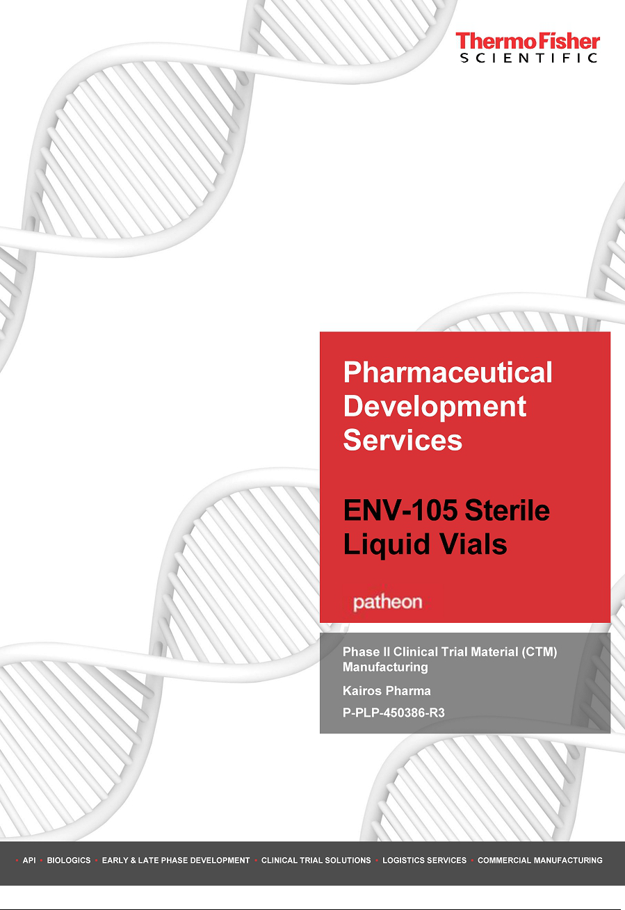

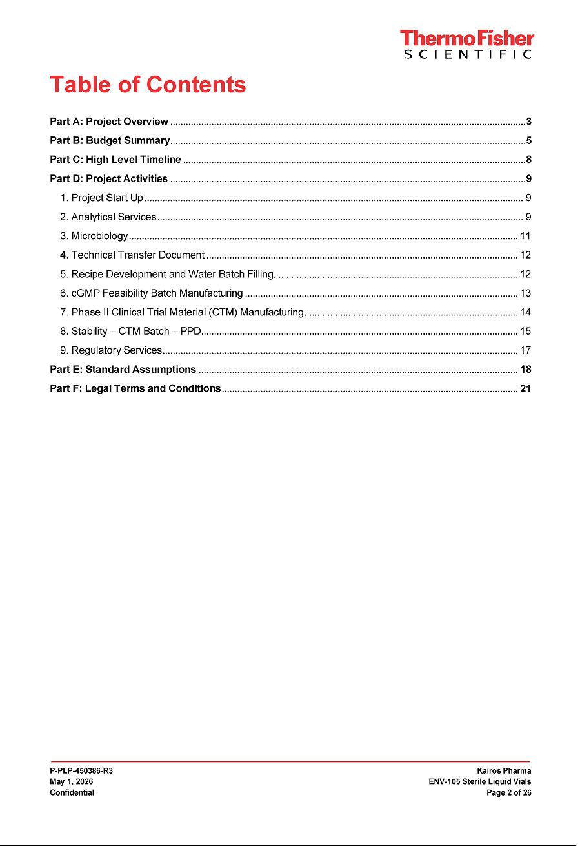

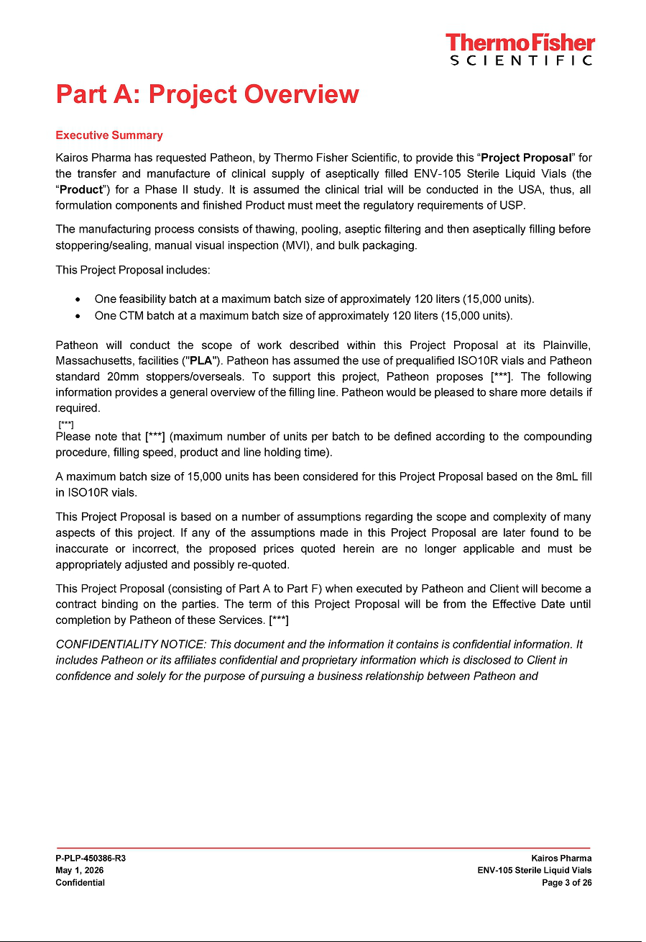

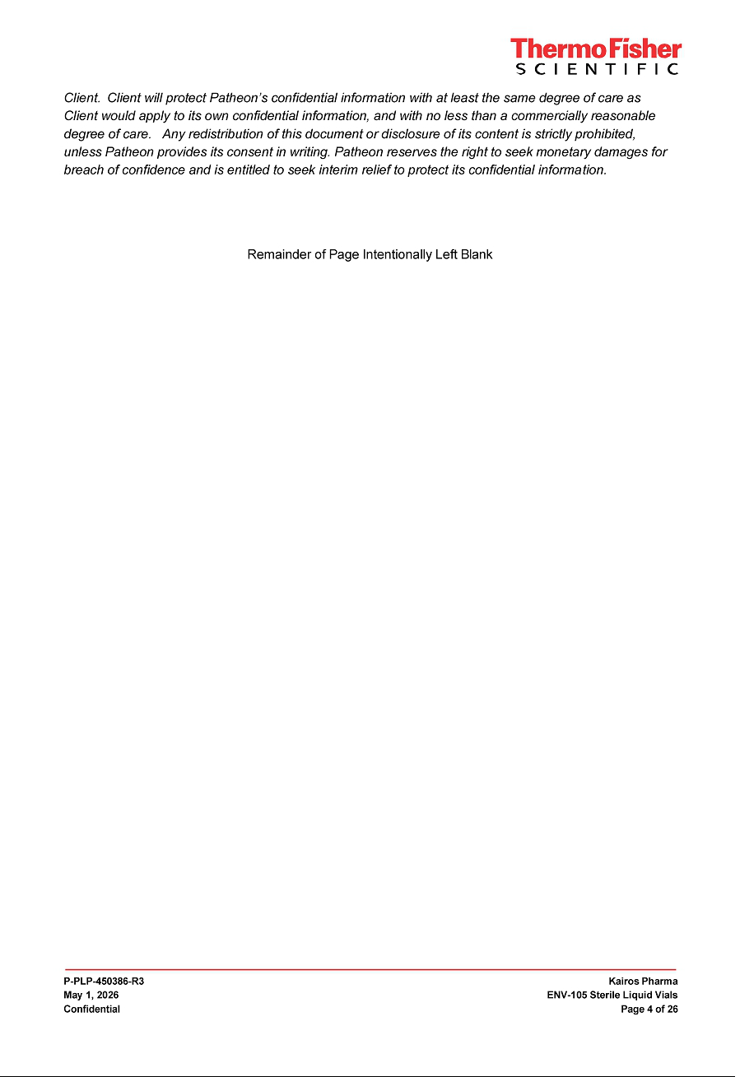

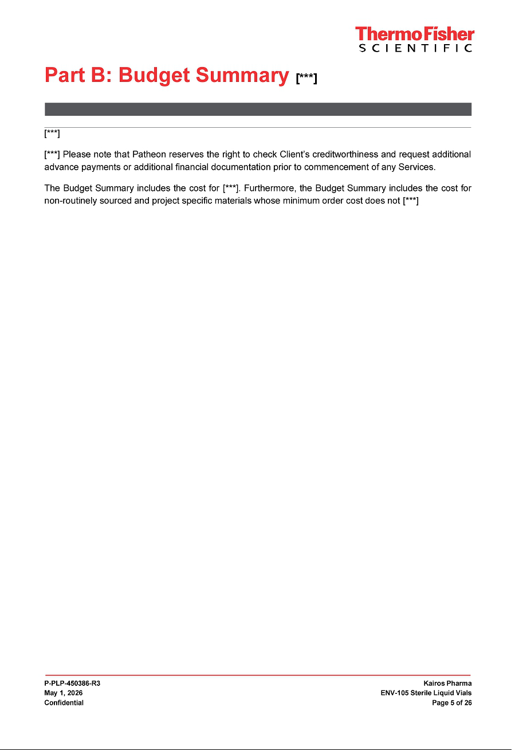

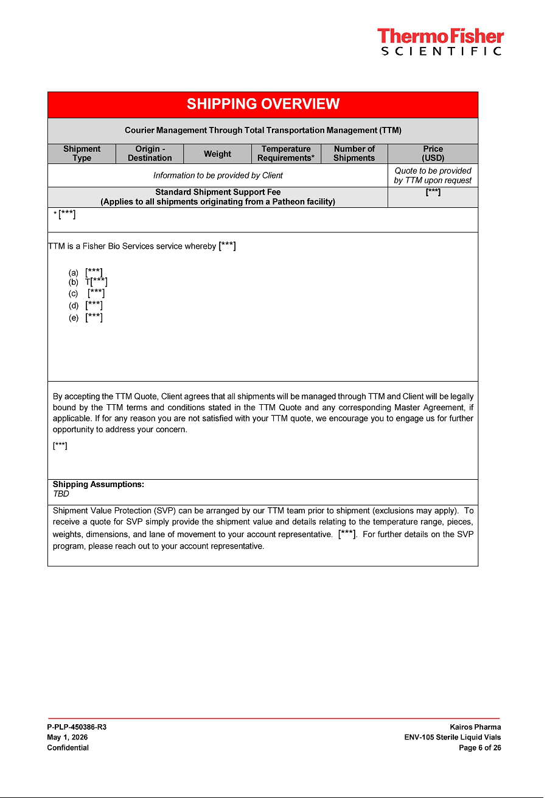

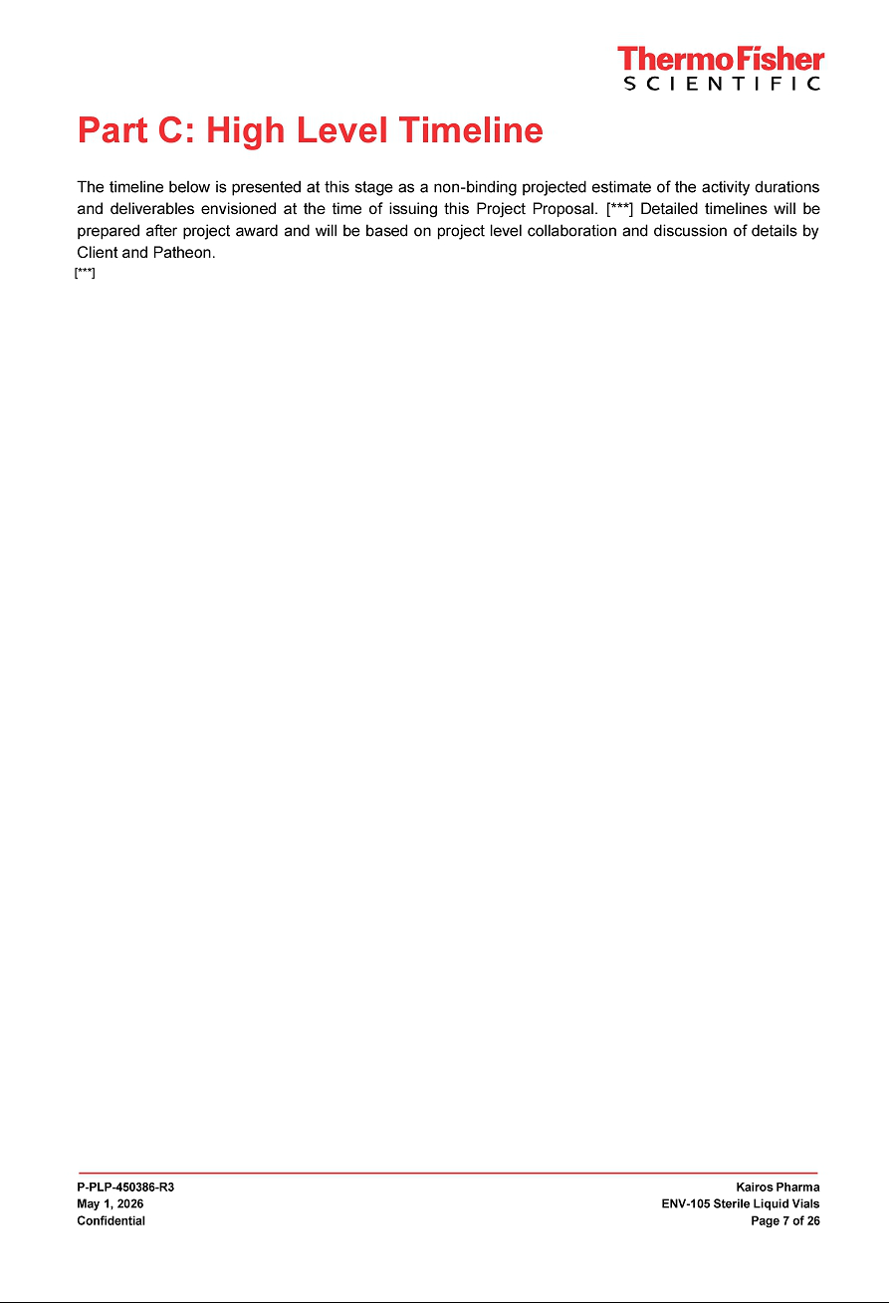

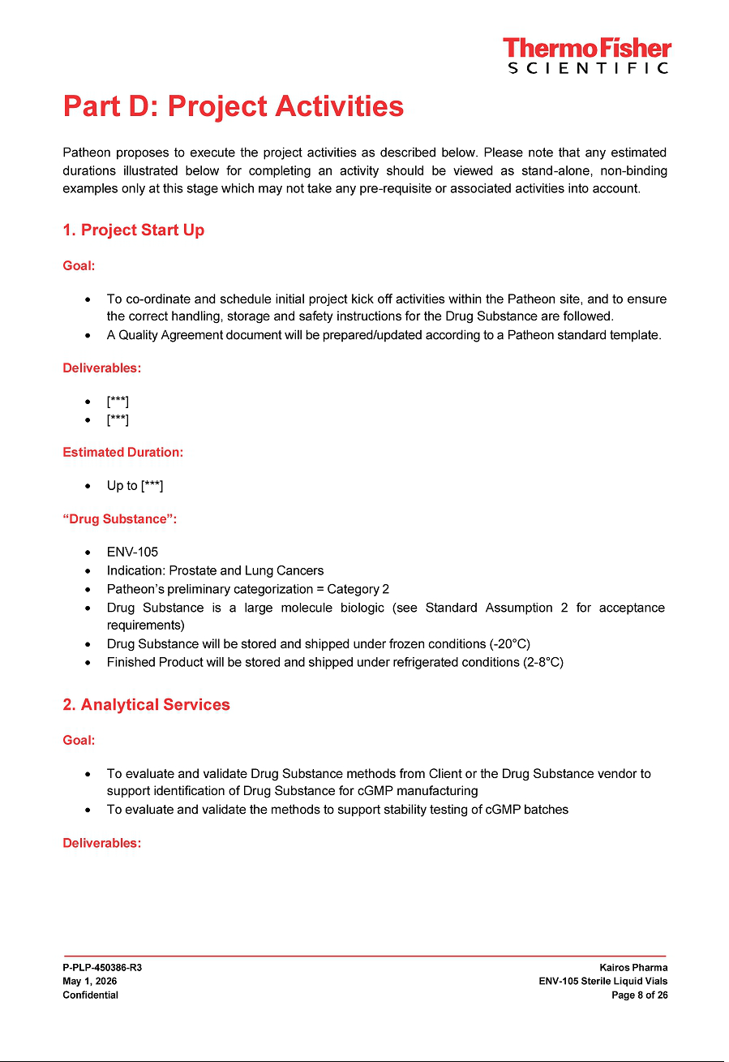

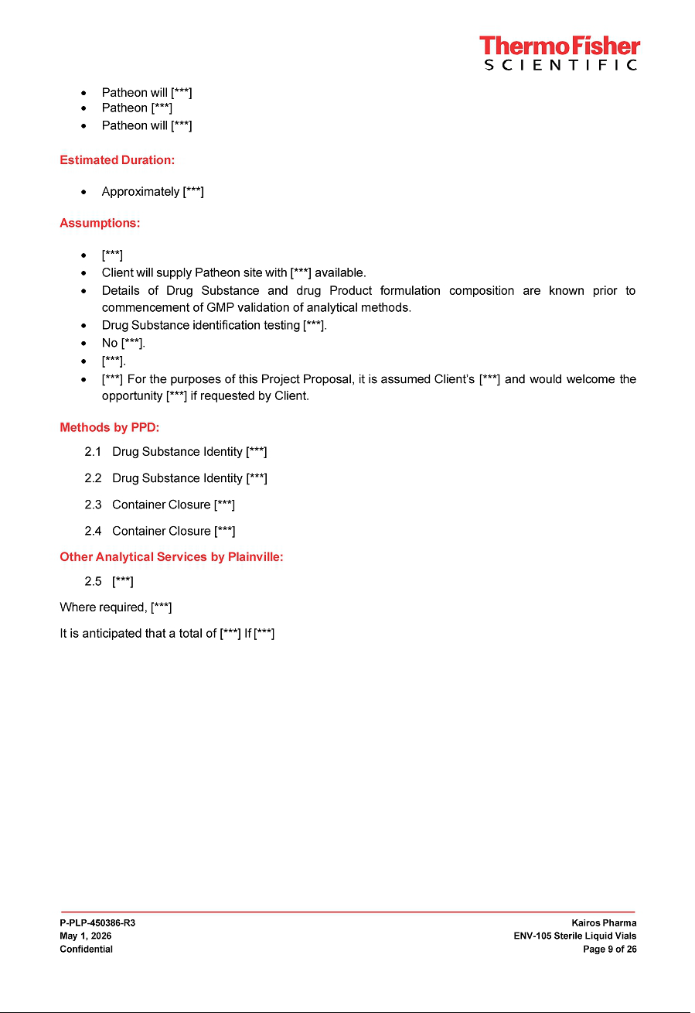

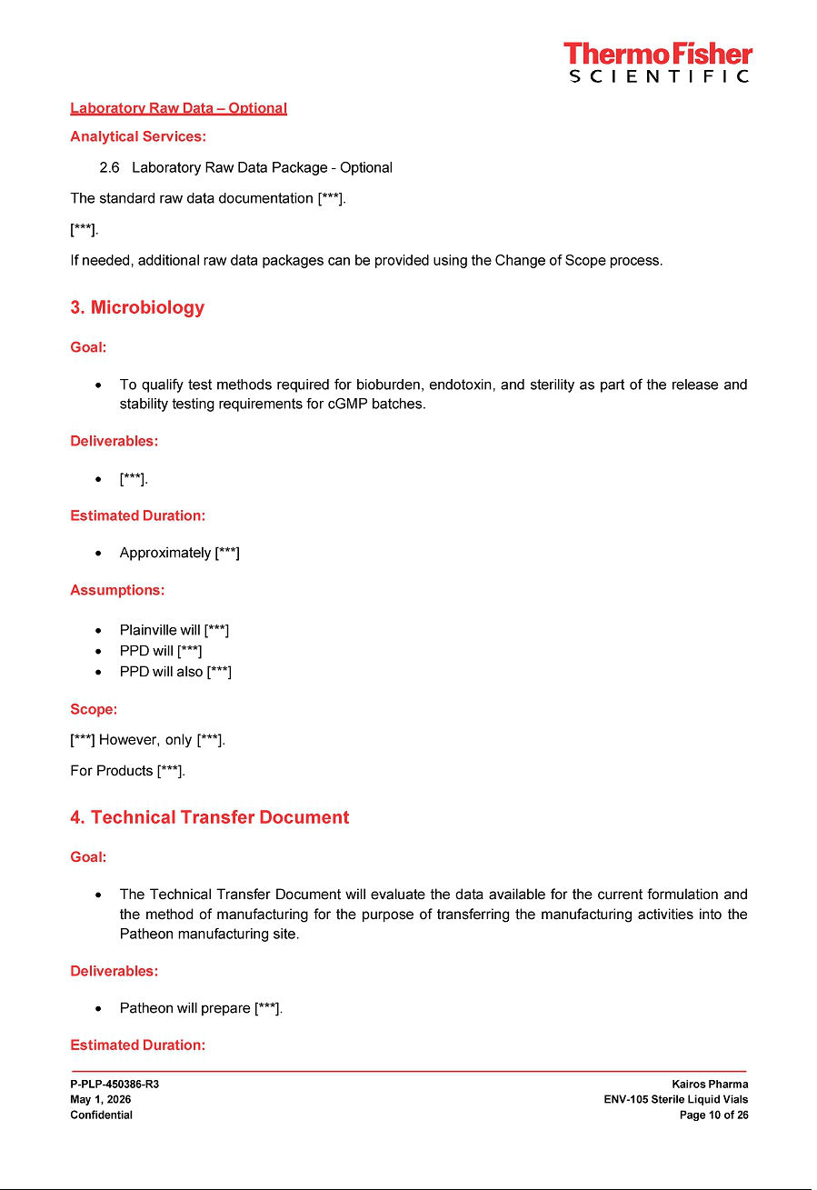

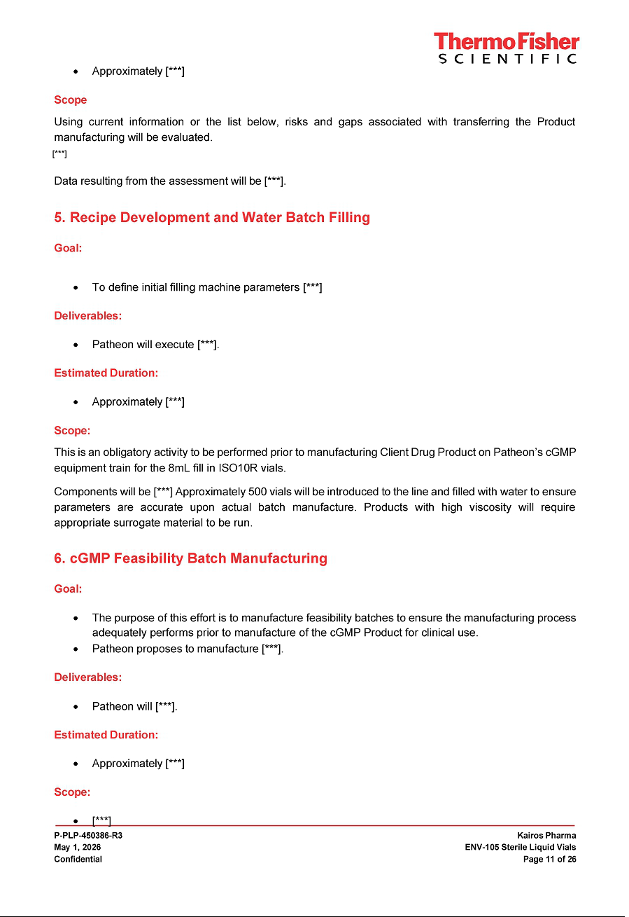

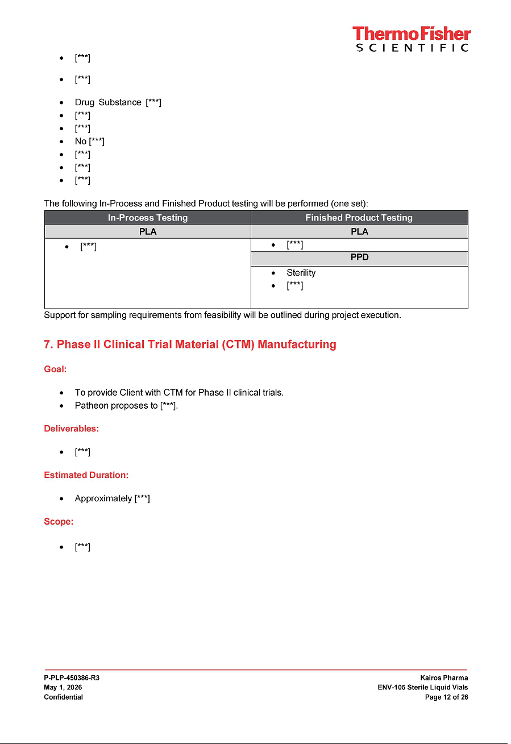

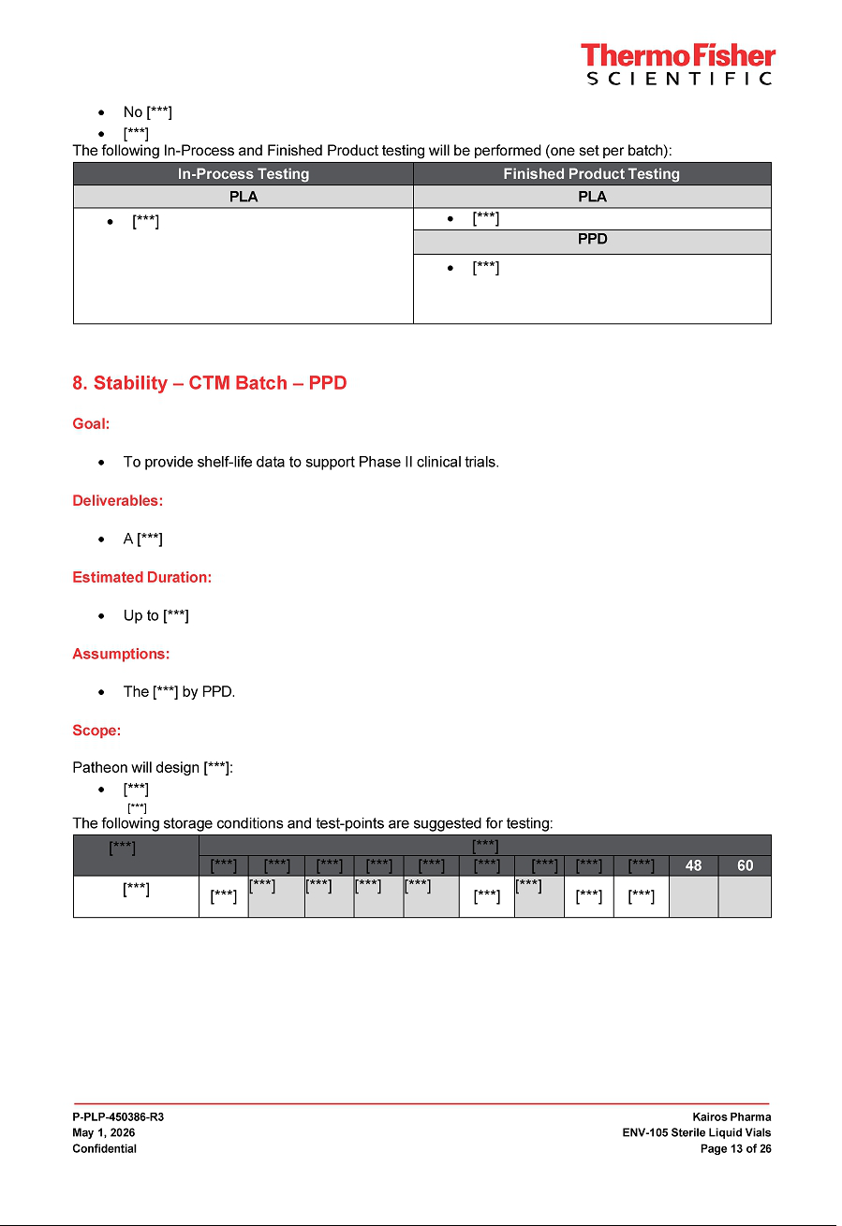

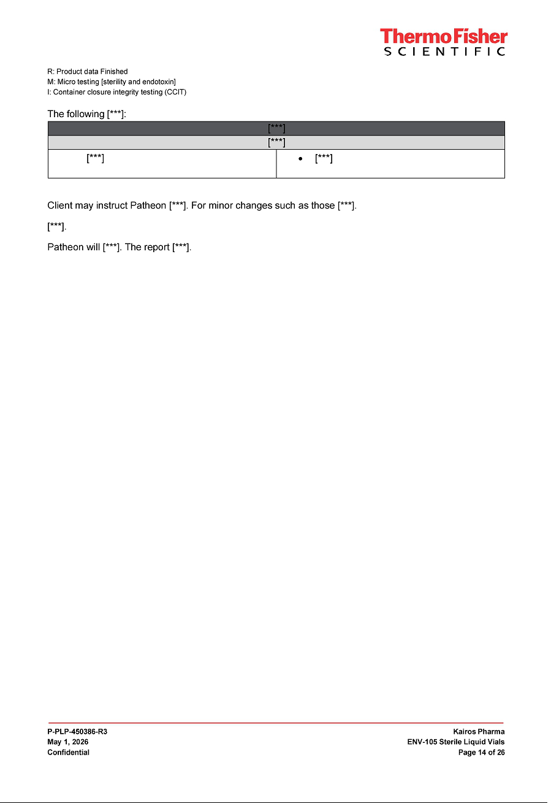

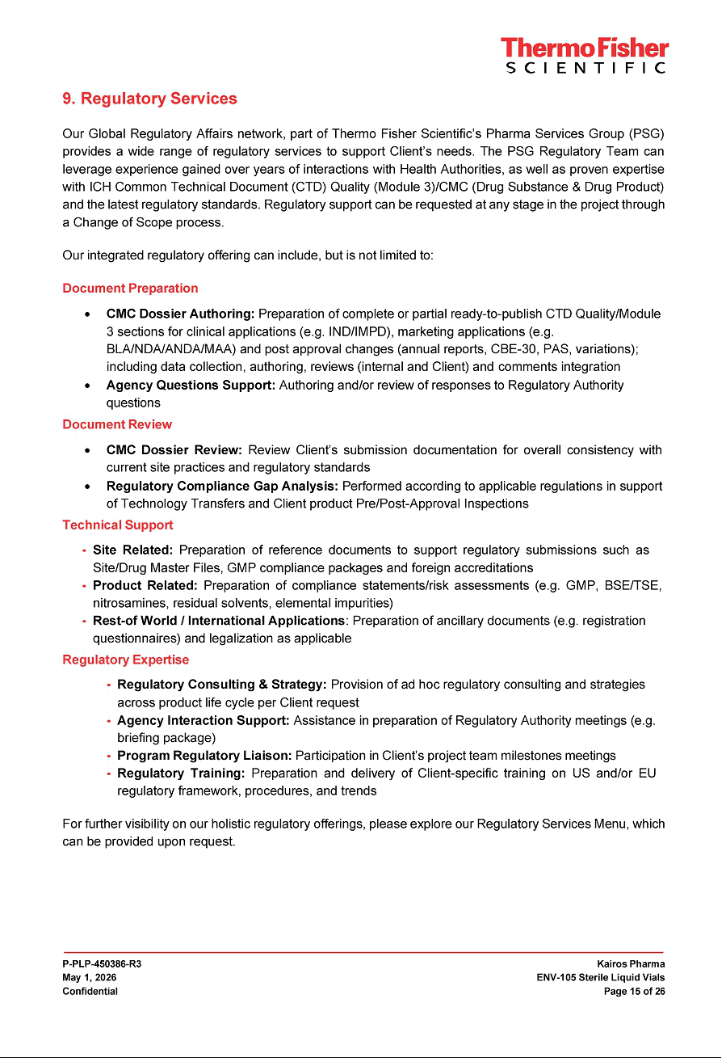

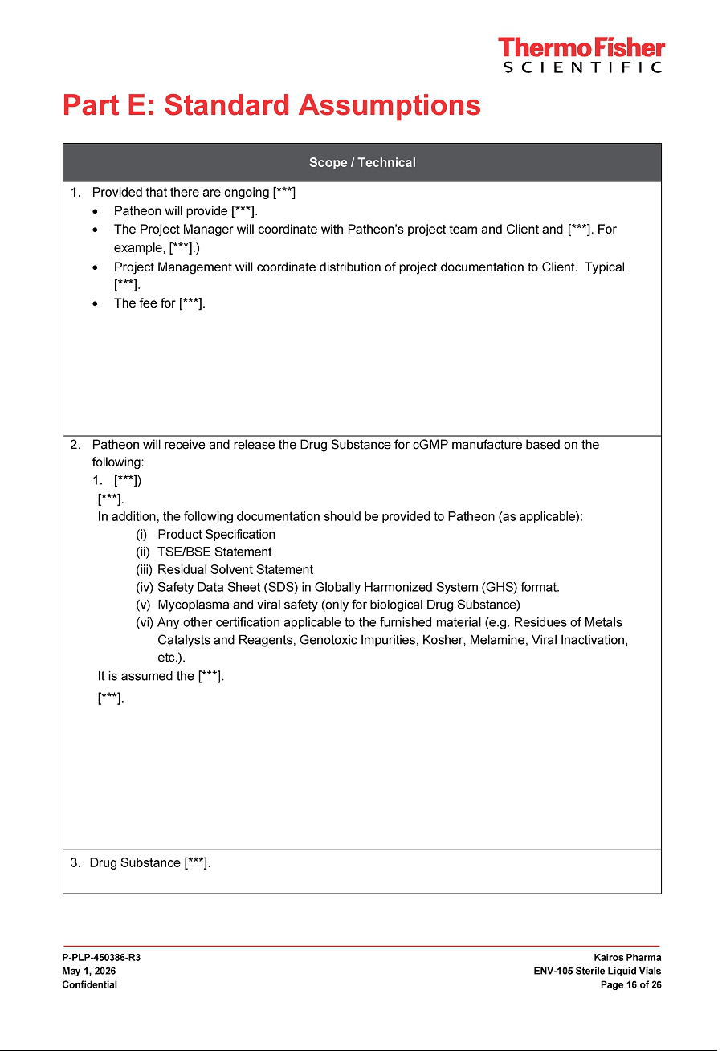

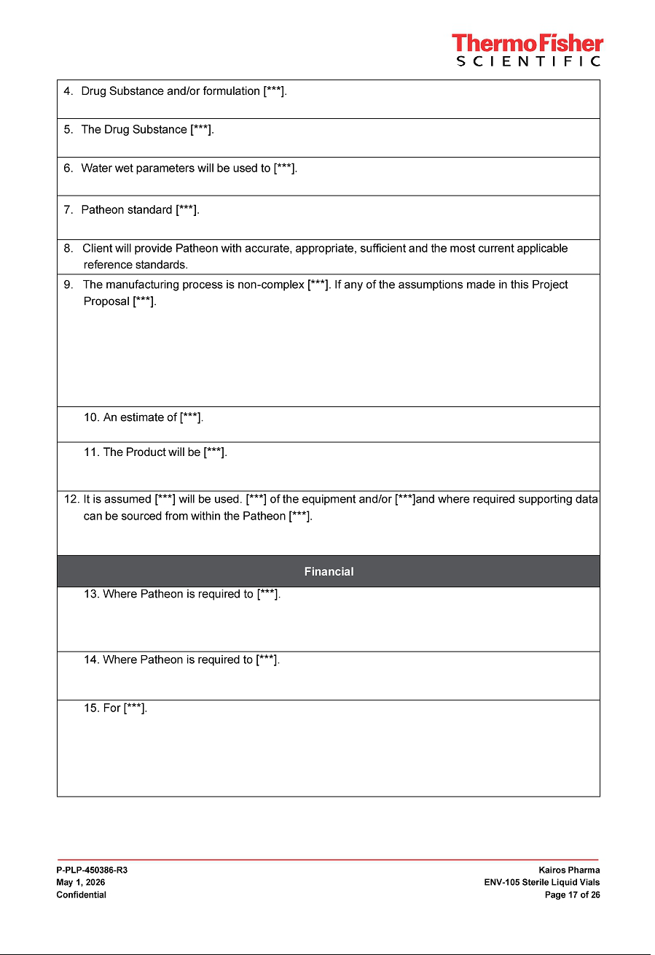

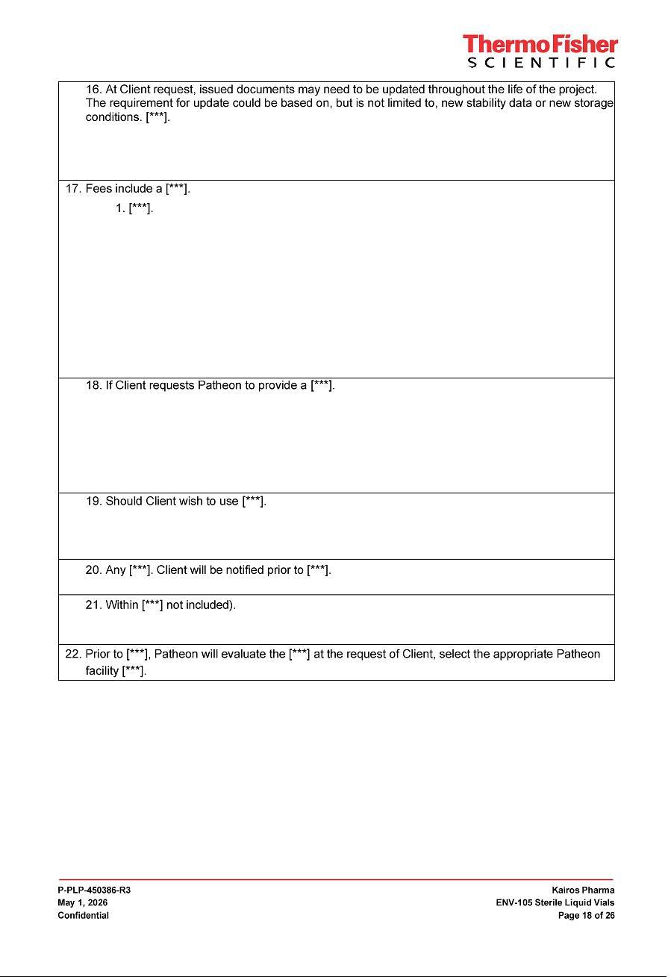

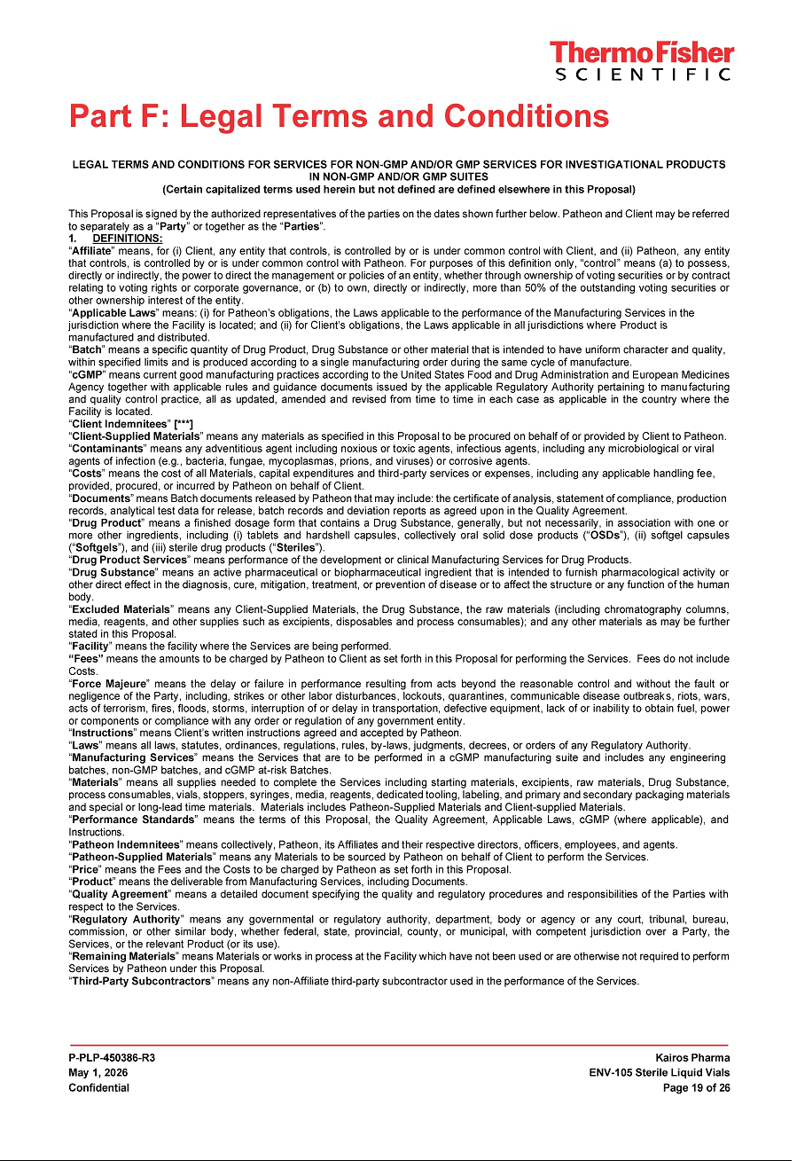

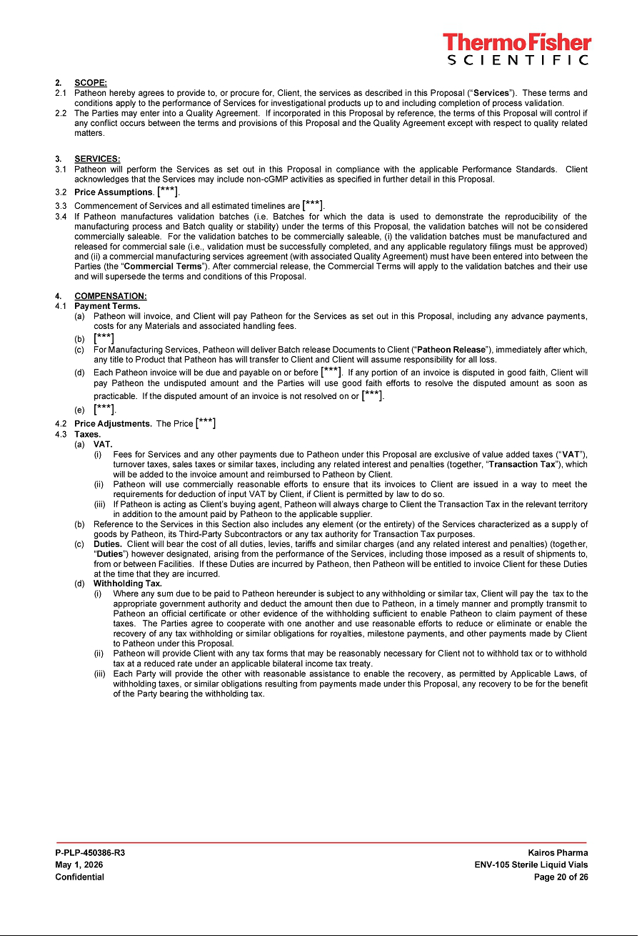

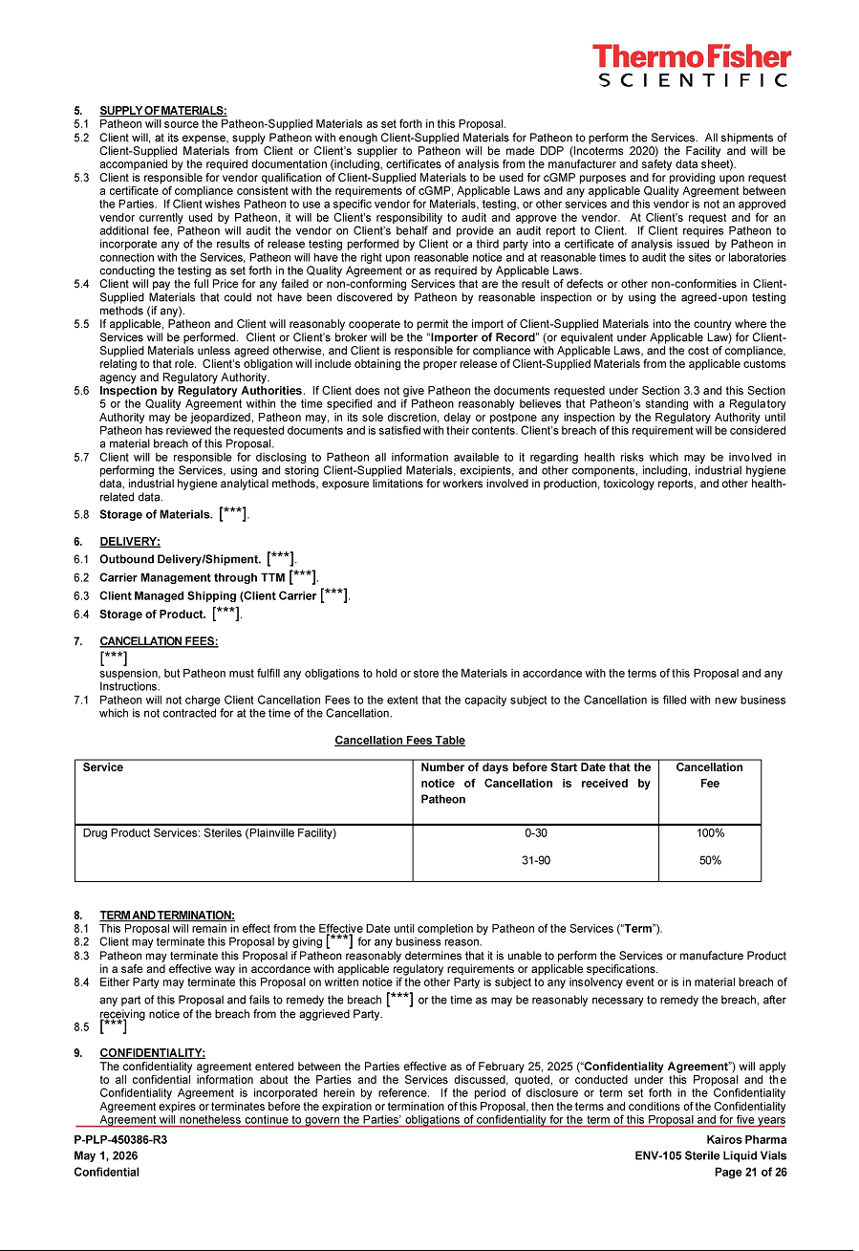

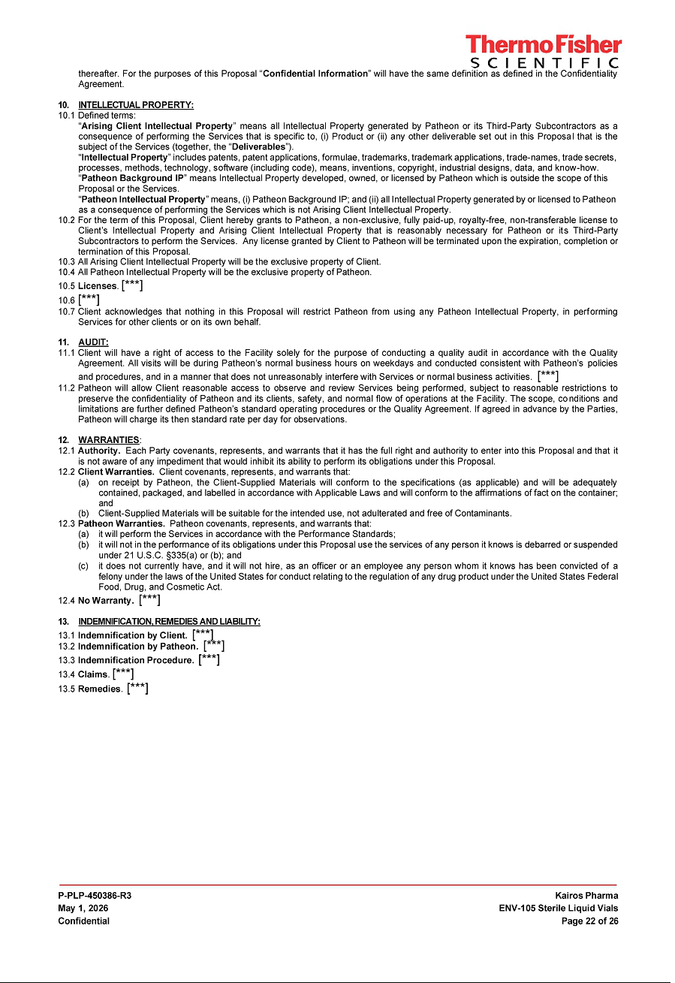

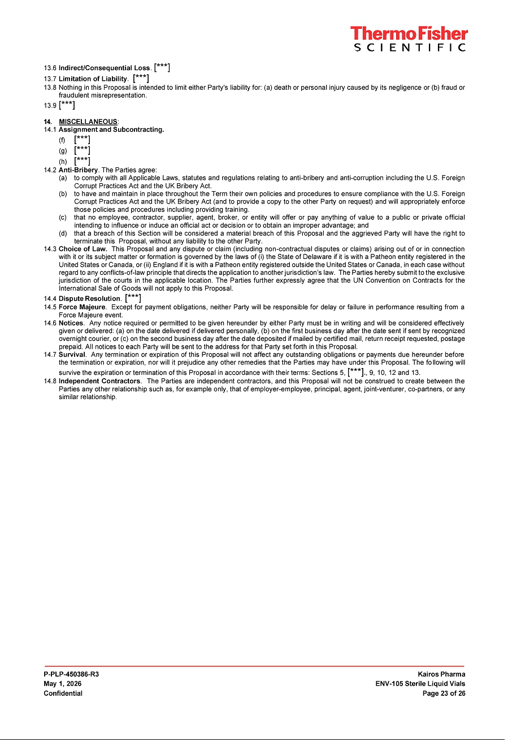

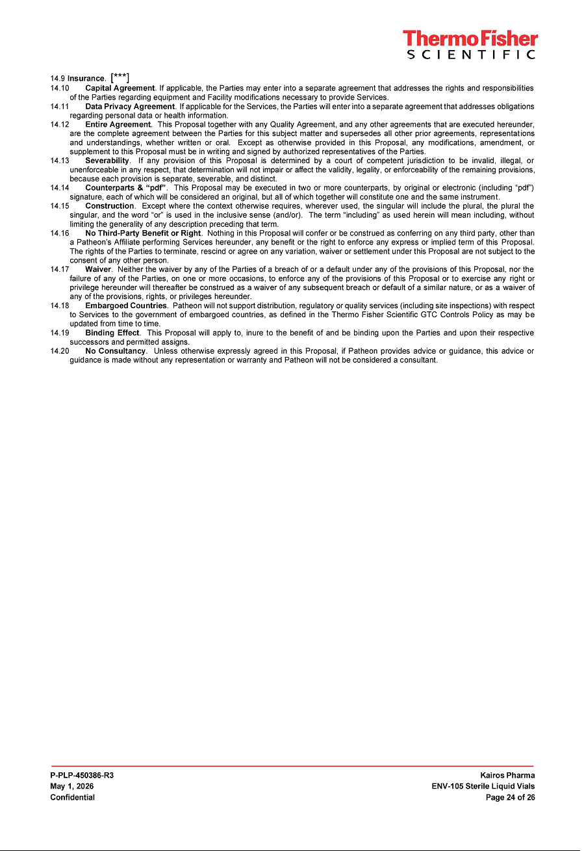

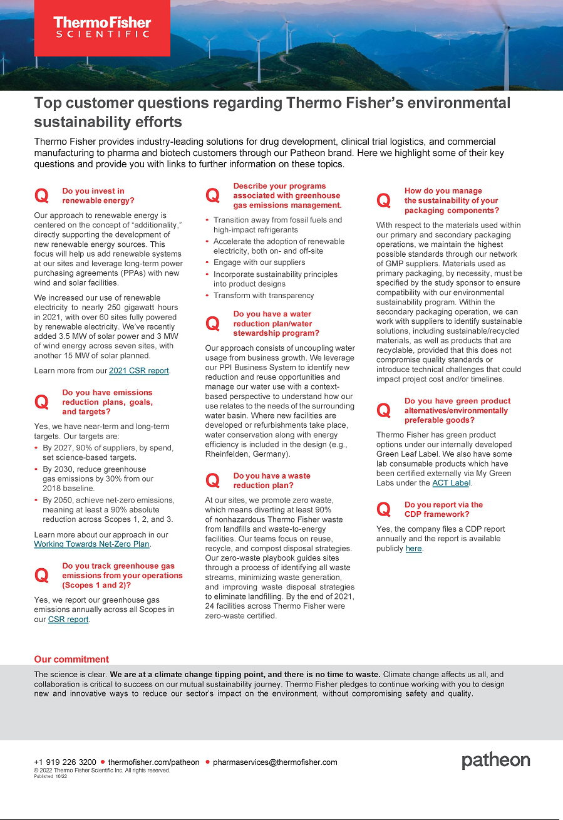

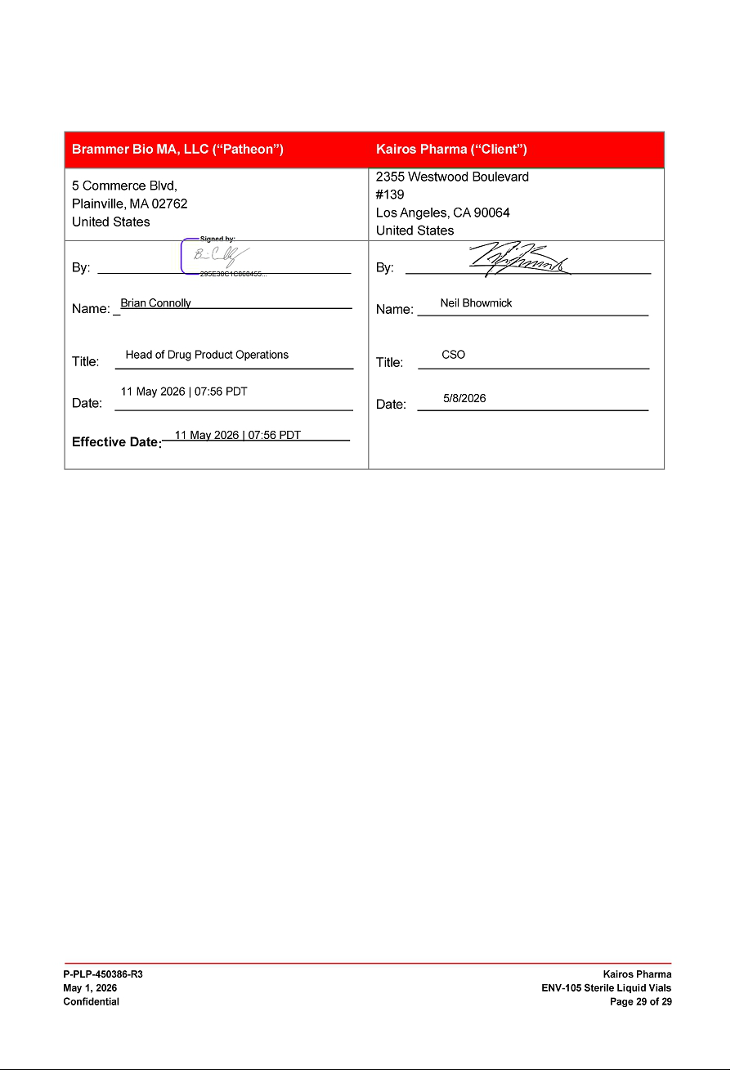

Exhibit 31.1

CERTIFICATION

I, John S. Yu, certify that:

- I have reviewed this Quarterly Report on Form 10-Q of Kairos Pharma, Ltd.;

- Based on my knowledge, this report does not contain any untrue statement of a material fact or omit to state a material fact necessary to make the statements made, in light of the circumstances under which such statements were made, not misleading with respect to the period covered by this report;

- Based on my knowledge, the financial statements, and other financial information included in this report, fairly present in all material respects the financial condition, results of operations and cash flows of the registrant as of, and for, the periods presented in this report;

- The registrant’s other certifying officer and I are responsible for establishing and maintaining disclosure controls and procedures (as defined in Exchange Act Rules

13a-15(e) and 15d-15(e)) and internal control over financial reporting (as defined in Exchange Act Rules 13a-15(r) and 15d-15(r)) for the registrant and have:

- Designed such disclosure controls and procedures, or caused such disclosure controls and procedures to be designed under our supervision, to ensure that material information relating to the registrant, including its consolidated subsidiaries, is made known to us by others within those entities, particularly during the period in which this report is being prepared;

- Designed such internal control over financial reporting, or caused such internal control over financial reporting to be designed under our supervision, to provide reasonable assurance regarding the reliability of financial reporting and the preparation of financial statements for external purposes in accordance with generally accepted accounting principles;

- Evaluated the effectiveness of the registrant’s disclosure controls and procedures and presented in this report our conclusions about the effectiveness of the disclosure controls and procedures, as of the end of the period covered by this report based on such evaluation; and

- Disclosed in this report any change in the registrant’s internal control over financial reporting that occurred during the registrant’s most recent fiscal quarter (the registrant’s fourth fiscal quarter in the case of an annual report) that has materially affected, or is reasonably likely to materially affect, the registrant’s internal control over financial reporting; and

- The registrant’s other certifying officer and I have disclosed, based on our most recent evaluation of internal control over financial reporting, to the registrant’s auditors and the audit committee of the registrant’s board of directors (or persons performing the equivalent functions):

- All significant deficiencies and material weaknesses in the design or operation of internal control over financial reporting which are reasonably likely to adversely affect the registrant’s ability to record, process, summarize and report financial information; and

- Any fraud, whether or not material, that involves management or other employees who have a significant role in the registrant’s internal control over financial reporting.

Date: May 13, 2026

By: /s/ John S. Yu

John S. Yu
Chief Executive Officer and Chairman of the Board of Directors

(principal executive officer)

Exhibit 31.2

CERTIFICATION PURSUANT

I, Douglas Samuelson, certify that:

- I have reviewed this Quarterly Report on Form 10-Q of Kairos Pharma, Ltd.:

- Based on my knowledge, this report does not contain any untrue statement of a material fact or omit to state a material fact necessary to make the statements made, in light of the circumstances under which such statements were made, not misleading with respect to the period covered by this report;

- Based on my knowledge, the financial statements, and other financial information included in this report, fairly present in all material respects the financial condition, results of operations and cash flows of the registrant as of, and for, the periods presented in this report;

- The registrant’s other certifying officer and I are responsible for establishing and maintaining disclosure controls and procedures (as defined in Exchange Act Rules

13a-15(e) and 15d-15(e)) and internal control over financial reporting (as defined in Exchange Act Rules 13a-15(r) and 15d-15(r) for the registrant and have:

- Designed such disclosure controls and procedures, or caused such disclosure controls and procedures to be designed under our supervision, to ensure that material information relating to the registrant, including its consolidated subsidiaries, is made known to us by others within those entities, particularly during the period in which this report is being prepared;

- Designed such internal control over financial reporting, or caused such internal control over financial reporting to be designed under our supervision, to provide reasonable assurance regarding the reliability of financial reporting and the preparation of financial statements for external purposes in accordance with generally accepted accounting principles;

- Evaluated the effectiveness of the registrant’s disclosure controls and procedures and presented in this report our conclusions about the effectiveness of the disclosure controls and procedures, as of the end of the period covered by this report based on such evaluation; and

- Disclosed in this report any change in the registrant’s internal control over financial reporting that occurred during the registrant’s most recent fiscal quarter (the registrant’s fourth fiscal quarter in the case of an annual report) that has materially affected, or is reasonably likely to materially affect, the registrant’s internal control over financial reporting; and

- The registrant’s other certifying officer and I have disclosed, based on our most recent evaluation of internal control over financial reporting, to the registrant’s auditors and the audit committee of the registrant’s board of directors (or persons performing the equivalent functions):

- All significant deficiencies and material weaknesses in the design or operation of internal control over financial reporting which are reasonably likely to adversely affect the registrant’s ability to record, process, summarize and report financial information; and

- Any fraud, whether or not material, that involves management or other employees who have a significant role in the registrant’s internal control over financial reporting.

Date: May 13, 2026

By: /s/ Douglas Samuelson

Douglas Samuelson
Chief Financial Officer

(Principal Financial and Accounting Officer)

Exhibit 32.1

CERTIFICATION PURSUANT TO

18 U.S.C. SECTION 1350,

AS ADOPTED PURSUANT TO

SECTION 906 OF THE SARBANES-OXLEY ACT OF 2002

In connection with the Quarterly Report of Kairos Pharma, Ltd. (the “Company”) on Form 10-Q pursuant to Rule 15d-2 under the Securities Exchange Act of 1934, as filed with the Securities and Exchange Commission on the date hereof (the “Report”), I, John S. Yu, Chief Executive Officer of the Company, certify, pursuant to 18 U.S.C. Section 1350, as adopted pursuant to Section 906 of the Sarbanes-Oxley Act of 2002, that:

- The Report fully complies with the requirements of Section 13(a) or 15(d) of the Securities Exchange Act of 1934; and

- The information contained in the Report fairly presents, in all material respects, the financial condition and results of operations of the Company. Date: May 13, 2026

/s/ John S. Yu

John S. Yu
Chief Executive Officer and Chairman of the Board of Directors

(principal executive officer)

Exhibit 32.2

CERTIFICATION PURSUANT TO

18 U.S.C. SECTION 1350,

AS ADOPTED PURSUANT TO

SECTION 906 OF THE SARBANES-OXLEY ACT OF 2002

In connection with the Quarterly Report of Kairos Pharma, Ltd. (the “Company”) on Form 10-Q pursuant to Rule 15d-2 under the Securities Exchange Act of 1934, as filed with the Securities and Exchange Commission on the date hereof (the “Report”), I, Douglas Samuelson, Chief Financial Officer of the Company, certify, pursuant to 18 U.S.C. Section 1350, as adopted pursuant to Section 906 of the Sarbanes-Oxley Act of 2002, that:

- The Report fully complies with the requirements of Section 13(a) or 15(d) of the Securities Exchange Act of 1934; and

- The information contained in the Report fairly presents, in all material respects, the financial condition and results of operations of the Company. Date: May 13, 2026

/s/ Douglas Samuelson

Douglas Samuelson
Chief Financial Officer

(Principal Financial and Accounting Officer)

